Operations

Overview

The Accounts Receivable Operations section contains a description of all Accounts Receivable tasks. For each task, a sample screen is shown followed by a description of each field and an explanation on how the task operates. Additionally, an example of all reports and registers is provided in Appendix A. This section can be used as a reference when using any of the Accounts Receivable tasks. Refer to the AddonSoftware Administrator manual for basic operating instructions on how to select a task or how to move about a screen.

A complete understanding of the Accounts Receivable module is easier if the Introduction, Installation and Flow of Processing sections are studied in conjunction with the Operations section. Because the Accounts Receivable module is integrated closely with the Order/Invoice Processing and Sales Analysis modules, many of the features described here are more meaningful when used in conjunction with those modules.

The tasks shown here are organized according to how they appear on the menu in a standard installation of the software. Because the AddonSoftware menu system permits customization of the description and organization of the menus, your system may vary slightly from the information presented here.

Accounts Receivable Main Menu
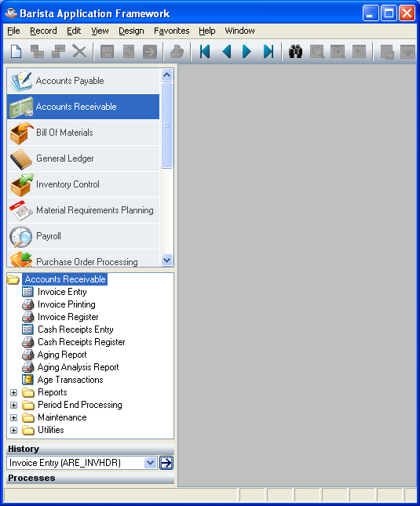

Accounts Receivable Main Menu

Function
The Accounts Receivable main menu provides access to most tasks in the Accounts Receivable module, including the Period-End Processing and Accounts Receivable Maintenance menu.

n To access Accounts Receivable....

Select Accounts Receivable from the AddonSoftware Menu Options.

Simple Invoice Entry
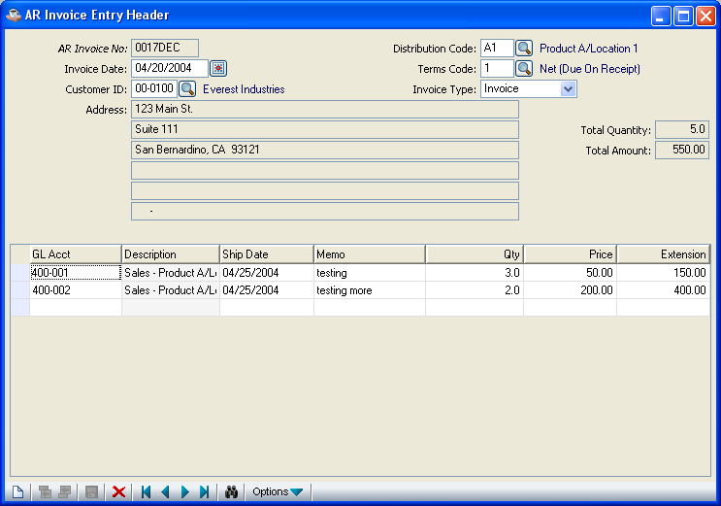
Simple Invoice Entry

Function
The Simple Invoice Entry task provides simple invoicing functions in the Accounts Receivable module when billing integrated with the Inventory Control module is not required. Detailed line items may be entered in the body of the invoice, each having a separate general ledger revenue account, service date, description, quantity, price and extension. Invoices may be printed on plain paper (8-1/2 by 11”) without special forms.

n To access Simple Invoice Entry...

Select Invoice Entry from the Accounts Receivable processing menu.

About the Fields

In the Invoice No field...
• Enter a seven-digit invoice number.
-or-
Press the Record Query button to select the existing invoice numbers.
-or-

Press ctl-F4 or click the close window icon to return to the Accounts Receivable main menu.

When the invoice number already exists but has not yet been updated, the invoice heading information is displayed. The invoice can be added to, modified or deleted.

A new invoice number can be assigned manually:

In the Invoice Date field...
• Enter the date of the invoice.

This date is used to specify the general ledger posting date for the invoice.

In the Customer Number field...
• Enter a valid customer number. (Refer to Accounts Receivable Customer Maintenance.)
-or-
Press the Find Field Records button to select from a list of all valid customer numbers.

In the Name field...
Display only. Shows the name of the customer associated with the customer number.

In the Address field...
Display only. Shows the address of the customer associated with the customer number.

In the City field...
Display only. Shows the name of the city associated with the customer.

In the State field...
Display only. Shows the state associated with the customer.

In the Zip/Postal field...
Display only. Shows the zip/postal code associated with the customer address.

In the Distribution Code field...
• Enter a valid distribution code.
-or-
Press the Find Field Records button to select from a list of all valid codes.

This code is used to specify the Accounts Receivable account when the invoice is updated and postings to the general ledger are created. (Refer to Distribution Code Maintenance task in the Accounts Receivable Maintenance section for additional information.) The description of the distribution code is displayed.

In the Terms Code field...
• Enter a valid terms code for the invoice. (Refer to Accounts Receivable Terms Code Maintenance.)
-or-
Press the Find Field Records button to select from a list of all valid codes.

The description of the terms code is displayed.

In the Total Quantity field…
Display only. Shows the total quantity associated with the customer.

In the Total Amound field…
Display only. Shows the total amount associated with the customer.

The following prompt is issued:

• After that you are entered to the GL Acct field.

Press ctl-F4 or click the close window icon to return to the Accounts Receivable main menu.

In the GL Account field...
When the General Ledger is installed:
• Enter a valid general ledger account number that (usually) represents the revenue posting account for this detail line.

The description of the account number is displayed.

In the Ship Date field...
• Enter the date of service or delivery of the product.

This date has no effect on the general ledger posting for the invoice.

In the Memo field...
• Enter a description of up to thirty characters to describe the product or service identified by the line. This description will print on the invoice.

In the Qty field...
Optional
• Enter the quantity for the invoice detail line, if applicable. The default is zero.

Example
Enter the number of hours if this is a labor charge that is billed per hour.

In the Price field...
Optional
• Enter the price per unit for the invoice detail line, if applicable. The default is zero.

Example
Enter the price per hour when it represents a labor charge that is billed by the hour.

In the Extension field...

This field shows the product of the Qty and Price fields.

Press the Add to end button to enter other invoice items at the end
-or-
Press the Insert Before button to insert invoice items on before.

Press the Delete Current Record button
to remove the line.

When you have finished making invoice entries, Press the Save Current Data button to save the invoice details.
-or-

Press the New/Clear form button to return to the Invoice No. field where you may enter another invoice
-or-

Press ctl- F4 or click the close window icon to return to the Accounts Receivable main menu.
or

Press the Re-calculate Totals button 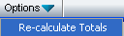 to recalculate the total of all quantities and extensions for the invoice.

Simple Invoice Printing
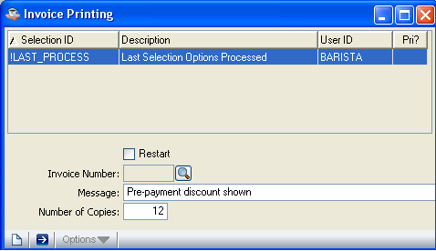

Simple Invoice Printing

Function
All entered invoices are printed through Simple Invoice Entry. This task allows you to restart from a selected invoice and to print on 8-1/2 by 11” continuous paper. Special forms are not required. Refer to Appendix A, page 5-3, for a sample copy of the printed invoices.

n To access the Simple Invoice Printing task...

Select Invoice Printing from the Accounts Receivable processing menu.

About the Fields

In the Restart <Y/N> field...
• Check ( Y )to restart the invoice printing beginning with a specific invoice number.
-or-
Uncheck (N) to start printing from the first invoice number (this is the normal option).
-or-
Press ctl-F4 to return to the menu.

NOTE: The restart option is only used in the event of a paper jam or a torn invoice.

In the Invoice Number field...
• Enter a valid invoice number to restart printing.

This option is only used when the restart question is checked as (Y).

In the Message field...
Optional
• Enter a general message of up to thirty characters in length to be printed at the bottom of each invoice.

Example
Messages announcing changes in company policies or special events can be printed on all invoices.

In the Number of Copies field...
• Enter the number of copies you want to print for each invoice.

This option is valuable when you are printing on single sheet paper and require more than one printed copy.

The following prompt is issued:

• Press to print the invoices.
-or-
Press to New/Clear form .
-or-
Press ctl-F4 to return to the menu.

Printing
As the invoices print, “Invoice Printing” is displayed on the progress bar to indicate the progress of the printing.

Simple Invoice Register
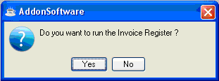
Simple Invoice Register

Function
The Simple Invoice Register prints a register of all invoices entered through Simple Invoice Entry (including voided invoices). There are no entry fields with this task. The register begins printing as soon as you respond affirmatively to the prompt. Refer to Appendix A, page 5-4 and 5-5, for a sample copy of the printed register.

n To access the Simple Invoice Register...

Select Invoice Register from the Accounts Receivable processing menu.

The prompt issued reads:

• Press to print the register.
-or-
Press to return to the menu without printing.

Printing
As the invoices print, “Invoice Printing” is displayed on the progress bar to indicate the progress of the printing.

Once the register is printed, the following prompt is issued:

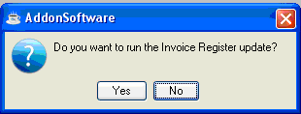

• Press to update the invoices.
-or-
Press to return to the menu without updating.

NOTE: If you do not update the register at this time it is necessary for you to run the register again in order to update the invoices on this register.

Updating
The act of updating posts the total of each invoice to the accounts receivable open invoice file. Prompt payment discount amounts and due dates are calculated based on the terms code associated with each invoice. The update also posts the extension amount from each invoice detail line to the general ledger sales account defined for each line. The offset posting for the total of all invoice detail line amounts is made to the receivables account defined by the distribution code associated with each invoice. As each invoice is updated, the progress bar indicate the progress of the update.

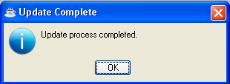

Cash Receipts Entry
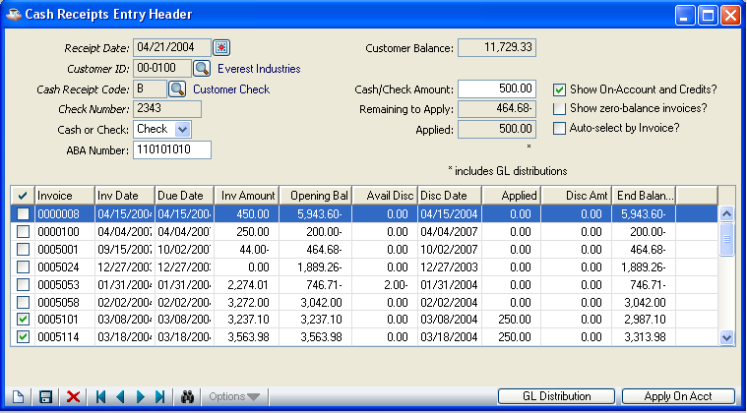
Cash Receipts Entry

Function
The Cash Receipts Entry task allows entry of payments and adjustments to a customer’s account. The heading section defines the customer, date and transaction information. Once the heading information has been entered, this task has two separate displays that allow invoice entry or general ledger postings.

The AR Distribution display allows application of payments and credits to invoices and on-account. The GL Distribution display allows posting of miscellaneous transactions directly to general ledger accounts.

n To access the Cash Receipts Entry...

Select Cash Receipts Entry from the Accounts Receivable processing menu.

About the Fields

NOTE: GL Distribution displays when pressing the button of GL Distribution in Cash Recepiets Entry Header.

Customer Information

In the Receipt Date field...
• Press to enter the date that the receipt is posted to the general ledger.
-or-
Press ctl-F4 to return to the Accounts Receivable main menu.

The Cash Receipts Register is sorted by Receipt Date to allow you to associate receipts transactions with their corresponding general ledger postings. The Receipt Date is also used to determine whether or not a discount has expired for a particular invoice. Because the Receipt Date is also used to identify cash being applied on-account, only one on-account payment may be made per customer per receipt date. Change the Receipt Date field to make subsequent on-account payments for a customer.

In the Customer ID field...
• Enter a valid customer number.
-or-
Press the Find Field Records button to select from a list of all valid customers.

In the Name field...
Display only. Shows the name of the customer whose number you entered in the Customer Number field.

In the Cash Rec Code field...
• Enter a valid three-character cash receipts code.
-or-
Press the Find Field Records button to select from a list of all valid codes.

The description of the code is displayed. This code is used to determine the cash account in the general ledger and parameters that affect the processing. Refer to Cash Receipts Code Maintenance task later in this section.

In the Check No field...
• Enter a check number or any other identifying number.

In the Cash/Check field...
• Select Check to indicate a check.
-or-
Select Cash for a cash transaction.

In the ABA Number field...
Optional
• Enter the bank identification number from the check.

This optional field prints on the Cash Receipts Register and is helpful in preparing the deposit slip.

In the Amount field...
• Enter the amount of cash received.

Adjustments, credit memos and other transfer transactions may not require a cash amount, depending on how the cash receipts code is defined. (Refer to note for Cash Rec Code.)

The following prompt is issued:

Is The Above Information Correct?

• Enter Y when the heading information is correct. The invoice payment fields are displayed.
-or-
Enter N to change the information beginning with the Cash Rec Code field.
-or-
Enter Delete to remove the entire transaction.

In the Balance field...
Display only. Shows the balance remaining to be applied to an invoice.

NOTE: A cash receipt transaction cannot be completed until this amount is equal to zero, thereby providing a check that your transaction is in balance.

AR Distribution Information

In the Invoice field...
• Enter a valid invoice number for the customer.
-or-
Enter L to select from a list of invoices on record for this customer. The following prompt is issued:

<CR>=List Invoices, <O>=List On-Account

Press Return to view all invoices. Records
-or-
Enter the letter O to view only those invoices on-account.
-or-
Enter A to automatically apply available cash amounts to open invoices, beginning with the oldest unpaid invoice.
-or-
Press F3 to apply cash on-account for the customer. The system will assign a number to the invoice such as: OAymmdd. (For instance: OA40331 for an invoice created in the year of 2004, during the month of March, on the 31st day.)
-or-
Press F4 when completing invoice entries.

Invoices are displayed with the invoice date, due date, current invoice amount and available payment terms discount. An invoice originally created with a terms discount is displayed if the cash receipts date is not after the discount due date.

When selecting individual invoices for payment, entries may be made for each of the following fields:

In the Applied field...
• Enter the amount of cash you want to apply to this invoice.
-or-
Press Return to apply cash up to the amount of the invoice, less available discount. If the cash is less than the invoice balance, the remaining amount is applied when pressing Return.

In the Discount field...
• Enter the amount of discount to be applied to the invoice.
-or-
Press Return to apply the available discount shown.

NOTE: The discount amount for an invoice is shown only when the cash receipts date is earlier than the discount expiration date as determined by the terms code associated with the invoice.

In the Balance field...
Display only. The remaining invoice balance is automatically calculated and displayed.

When you finish with the line entries, the following prompt is issued:

<CR>=OK, <F2>=Modify, <D>=Delete

• Press Return to accept the line entries.
-or-
Press F2 to make changes to the line.
-or-
Enter D to remove the line from the Cash Receipts Entry.

Once all entries to the line are accepted, the following prompt is issued:

Is The Above Information Correct?

• Enter Y when the above information is correct.
-or-
Enter N to make a change.
-or-
Enter GL to move to the GL Distribution display. (Refer to the GL Distribution Information parameter for more information.)
-or-
Enter Delete to remove the entire transaction and return to the Customer No field. You may make another entry or exit to the Main menu.

Applying On-Account Cash to Open Invoices
When using an existing on-account amount to pay invoices and there are no external funds being received, you should enter zero for the Amount field in the heading. Proceed with data entry as follows:

1. Apply payment to invoices in the usual manner. This will cause the Balance field in the heading to accumulate a negative amount if a zero deposit amount was originally entered.

- Enter the letter L at the Invoice field to view the on-account invoices.

- Enter O when the prompt reads:
Press <Enter> To List Invoices or “O” to List On-Account Records [_].

4. Type the on-account invoice number (OAymmdd) in the Invoice field and apply a negative amount to the on-account invoice in the same amount as applied to the invoices that were paid.

An existing on-account amount normally appears as a negative number that indicates a credit to the customer’s account. To use on-account, you apply a matching negative amount. As a result, the Balance field in the header is increased.

Applying Credit Memos to Open Invoices
When using an existing credit memo amount to pay invoices external funds are not being received, you should enter zero for the Amount field in the heading. Proceed with data entry as follows:

1. Apply payment to open invoices in the usual manner.

2. Call up the credit memo to be applied by entering its number at the Invoice field.

3. Apply a negative amount to the credit memo in the same amount as applied to the invoices that were paid.

Credit amounts normally appear as negative numbers indicating a credit to the customer’s accounts. To use the credit, you apply the matching negative amount. The Balance field in the header is increased as a result.

In a cash receipts transaction where cash is not actually received, the general ledger postings normally created by the application of payment (i.e. Debit to Cash, Credit to Receivables) are offset by the postings created when the credit is applied as payment (i.e. Debit to Receivables, Credit to Cash). The net result is that general ledger postings are not created. This is the desired result as the credit to receivables (and debit to sales) was made at the time the credit memo was originally updated.

GL Distribution Information
In addition to applying payment to individual invoices, the Accounts Receivable module allows you to enter general ledger postings as part of the cash receipts process. Entering GL when prompted at the bottom of the Cash Receipts Entry screen activates this function.
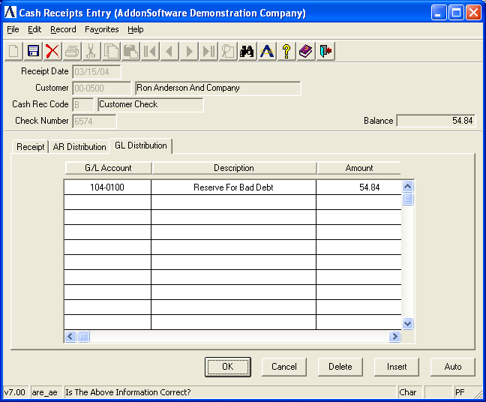

NOTE: GL Distribution is a parameter that is set when defining cash receipts codes. Refer to the Cash Receipts Codes Maintenance later in this section.

General ledger postings allow you to apply a remaining cash balance (or deficit) to a general ledger account(s), as in the case of writing off a non-collectible receivable item or granting additional discount on an invoice.

The GL Distribution display is useful when receiving cash that has no related sales transaction, such as a refund or general-purpose deposit. To facilitate the receipt of cash from miscellaneous sources, you should set up a special customer for this purpose called “Miscellaneous Cash” and use when appropriate.

About the Fields

In the GL Account field...
• Enter a valid general ledger account.
-or-
Press F3 to select from a list of valid accounts.
-or-
Press F4 to access the prompt that allows you to return to the AR Distribution display.

The description of the account is displayed.

In the Amount field...
• Enter the amount to be posted to this general ledger account.

Debits are indicated by positive numbers. Credits are indicated by negative numbers.

When you finish with the line entries, the following prompt is issued:

<CR>=OK, <F2>=Change, <D>=Delete

• Press Return to accept the line entries.
-or-
Enter D to remove the line from the GL Distribution entry.
-or-
Press F2 to make changes to the line.
-or-
Press F4 when you complete the GL entries.

Once all entries to the line are accepted, the following prompt is issued:

Is The Above Information Correct?

• Enter Y when the above information is correct. You are returned to the GL Account field.
-or-
Enter N to make a change. Changes are made by re-entering the general ledger account number and entering a different amount or entering zero to erase the previous entry.
-or-
Enter AR to return to the AR Distribution display.

Handling Checks with Non-sufficient Funds
Checks received with non-sufficient funds are generally not discovered until after the cash receipts are updated and the checks are deposited in the bank. When this occurs, you must make adjustments to the accounts receivable open invoice file and the general ledger as follows:

1. Refer to Accounts Receivable Utilities in the Operations section for instructions on how to enter the required information. You must have a security level of nine in order to access the utilities menu ARX. Use the Conversion Invoice Entry task to reinstate the invoice(s) that were paid by a bad check. Make sure you update only the open invoice file and not the general ledger (this would result in an incorrect posting).

2. Reverse the general ledger postings created by the cash receipts update process. To do this, use the Cash Receipts Entry task to give the invoice a zero deposit amount and use the GL Distribution display to adjust the general ledger accounts.

When paid invoices have a balance remaining or have not been purged from the open invoice file, they may be reinstated by performing Cash Receipts Entry using a negative deposit in the same amount as the bad check. Apply a negative amount for each invoice that was previously paid until the deposit balance is zero. Proceed with the Cash Receipts Register and update. This will both reinstate the invoices to their previous amounts and reverse the original general ledger postings that were made.

Cash Receipts Register
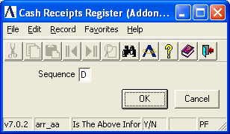

Cash Receipts Register

Function
The Cash Receipts Register prints a report of all cash receipts transactions entered through the Cash Receipts Entry task. If correct, all transactions are posted to the customer accounts, general ledger and optionally, the Bank Reconciliation system (in the General Ledger module). Refer to Appendix A, page 5-6 and 5-7, for a sample copy of the printed register.

n To access the Cash Receipts Register...

Select Cash Receipts Register from the Accounts Receivable processing menu.

About the Fields

In the Sequence field...
• Enter C to print the register by cash receipt code.
-or-
Enter D to print the register by receipt date.

The following prompt is issued:

Is the Above Information Correct?

• Enter Y when the information is correct and proceed with the printing.
-or-
Enter N and return to the Sequence field.

Once the register is printed, the following prompt is issued:

Are You Ready To Update The Cash Receipts Register?

• Enter Yes when the register printed correctly and to proceed with the update.
-or-
Enter No when the update should be postponed and to return to the Accounts Receivable menu without updating.

Updating
For each customer on the register, the amounts entered in the Cash Receipts Entry task are posted to their open invoices or on-account. The general ledger is posted as follows:

a) The cash account is determined by the cash receipts code.

b) The accounts receivable account is determined by the distribution code associated with the invoice when it was entered, not the current distribution code associated with the customer.

c) The terms discount account is determined by the cash receipts code associated with each cash receipt transaction.

d) In the case of cash posted on-account, the default distribution code associated with the customer determines the accounts receivable account.

e) Miscellaneous general ledger transactions are posted to the accounts entered through the Cash Receipts Entry GL Distribution display.

f) Transactions are written to the Cash Receipts History files.

When you have the Accounts Payable’s Bank Reconciliation and the Accounts Receivable module is interfaced to it, (Refer to Accounts Receivable Parameter Maintenance), a record of the cash received is posted to it. The month-to-date and/or next month cash receipt totals that appear at the bottom of the Cash Receipts Register are also updated at this time.

Aging Report

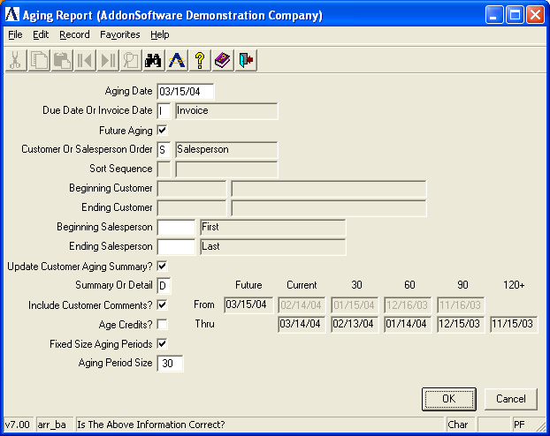

Aging Report

Function
The Aging Report prints an aged trial balance of customer accounts in either numeric or alphabetic sequence, with the option of displaying detail or summarized information for each customer. Refer to Appendix A, page 5-8, for a sample copy of the printed report.

n To access the Aging Report...

Select Aging Report from the Accounts Receivable processing menu.

About the Fields

In the Aging Date field...
• Enter the date upon which aging is based.

In the Age On Due Date Or Invoice Date field...
• Enter D to age all invoices based on their due date.
-or-
Enter I to age all invoices based on their invoice date.

NOTE: When using the aging report to help determine whether or not a customer should be assessed finance charges, pay close attention to the date selected for aging.

In the Future Aging field...
• Enter Y to include all invoices and payments regardless of their dates.
-or-
Enter N to exclude any accounts receivable transactions that occurred after the aging date for the report being run, such as a payment received after the end of the period.

NOTE: For an aging report that can be used to balance the accounts receivable general ledger account, select I in the Age On Due Date Or Invoice Date field and N in the Future Aging field.

Using the Graphical Interface:
- Click on the check box to indicate Yes, include all invoice and payments.
-or-
Press Enter to leave blank and proceed to the next field.

In the Customer Or Salesperson Order field...
• Enter C for a report sorted by customer number.
-or-
Enter S for a report sorted by salesperson code.

In the Sort Sequence field...
- Enter A to sort in alphabetical order.
-or-
Enter N to sort in numeric sequence by customer order numbers.

In the Beginning With field...
• Enter the first customer number to begin the report.
-or-
Press F1 to start with the first on file.
-or-
Press F3 to select from a list of all valid customers.

In the Ending With field...
• Enter the last customer number or salesperson code to end the report.
-or-
Press F1 to end with the last on file.
-or
Press F3 to select from a list of all valid customers.

NOTE: The Beginning and Ending fields represent lower and upper ranges that are printed, regardless of whether the report is printed in alphabetic or numeric sequence.

In the Update Customer Aging Summary field...
• Enter Y to update customer information.
-or-
Enter N to print the report without updating customer information.

Using the Graphical Interface:
- Click on the check box to indicate Yes, include all invoice and payments.
-or-
Press Enter to leave blank and proceed to the next field.

In the Summary Or Detail field...
• Enter S to print a single line for each customer.
-or-
Enter D to print all open invoices for each customer.

In the Include Customer Comments field...
• Enter Y to include comments on the report that are associated with the customer.
-or-
Enter N to print the report without customer comments.

Using the Graphical Interface:
- Click on the check box to indicate Yes, include comments associated with the customer.
-or-
Press Enter to leave blank and proceed to the next field.

In the Age Credits field...
- Enter Y to include credit balances on the printed report.
-or-
Enter N to print the report without credit balances.

Using the Graphical Interface:
- Click on the check box to indicate Yes, include credit balances on the printed report.
-or-
Press Enter to leave blank and proceed to the next field.

In the Fixed Size Aging Periods field...
- Enter Y to use fixed size for all buckets.
-or-
Enter N to enter date for each bucket separately.

Using the Graphical Interface:
- Click the check box to indicate Yes, and the system will automatically calculate using aging date and aging period size.
-or-
- Enter N to access aging periods and changes the dates.

In the Aging Period Size field...
- Enter the number of days for each aging bucket. The number must be at least one (1) and can range up to 999.

The system prompts:

Is The Above Information Correct?

• Enter Y to print the report.
-or-
Enter N to change the print options.
-or-
Press F4 to return to the menu.

Printing
As the Aging Report prints, the aging summary figures are recalculated for each customer and written to the Customer Masterfile when the response to the Update Customer Aging question is Yes.

Aging Analysis Report
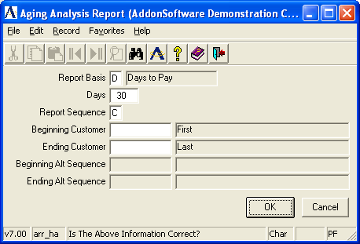

Aging Analysis Report

Function
The Customer Aging Analysis Report provides information on selected customers’ accounts receivable balance by aging period. Information is available by either average days to pay or balance by aging period. The report is available by customer number or alternate sequence sort. Refer to Appendix A, page 5-9, for a sample copy of the printed report.

n To access the Aging Analysis Report...

Select Aging Analysis Report from the Accounts Receivable processing menu.

About the Fields

In the Report Basis field...
• Enter D to select customers based on the average number of days to pay.
-or-
Enter A to select customers to print based on their current aging balance for the various aging categories (i.e. 30, 60, 90, etc.).

In the Days field...
• Enter the number of days that a customer must have in “average days to pay” in order to be included on the report.
-or-
Enter the number of the aging period (Future/Current/30/60/90/120) for which a customer must have a balance due in order to be included on the report.

Example
When you select D in the Report Basis field and enter 45 for the Days field, only customers with average days to pay of 45 or greater are included on the report.

When you select A in the Report Basis field and enter 90 for the Days field, only customers with a balance of 90 days or greater are included on the report.

In the Report Sequences field...
• Enter A to print the report sorted by customers in alternate sequence.
-or-
Enter C to print the report sorted in customer number sequence.

In the Beginning Customer field...
• Enter a number representing the first customer number to print.
-or-
Press F1 to begin with the first customer in the file.
-or-
Press F3 to select from a list of all valid customer numbers.

In the Ending Customer field...
• Enter a number representing the last customer number to include on the report.
-or-
Press F1 to end with the last customer on file.
-or-
Press F3 to select from a list of all valid customer numbers.

NOTE: The Begin With and End With fields represent a lower and upper range of customer numbers to print regardless of whether the report is printed in alphabetic or numeric sequence.

In the Beginning Alt Seq field...
- Enter a number representing an alternate sequence of customer numbers.
-or-
Press F1 to begin with the first customer number of file.

In the Ending Alt Seq field...
- Enter a number representing the end of the alternate sequence list of numbers.
-or
Press F1 to end with the last customer number on file.

The following prompt is issued:

Is The Above Information Correct?

• Enter Y when the report options are set correctly and proceed with the printing.
-or-
Enter N when the options are incorrect and you want to make a change.
-or-
Press F4 to return directly to the menu without printing the report.

Printing
As the report prints, customer numbers are displayed on the screen to show the progress.

Age Accounts Receivable Transactions
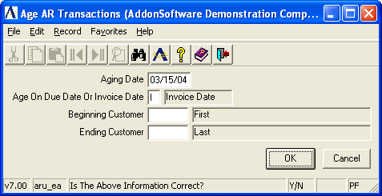
Age Accounts Receivable Transactions

Function
When the Accounts Receivable Aging Report is printed, the aging summary figures are recalculated for each customer and written to the Customer Masterfile. To recalculate the aging summary figures without printing an Aging Report, use the Age Accounts Receivable Transactions task. When desired, this task will also perform aging for a single customer or series of customers.

n To access the Age Accounts Receivable Transactions...

Select Age Accounts Receivable Transactions from the Accounts Receivable processing menu.

About the Fields

In the Aging Date field...
• Enter the date upon which aging is based.

In the Beginning Customer field...
• Enter the customer number with which to start the report.
-or-
Press F1 to start with the first customer number on file.
-or-
Press F3 to select from a list of all valid customer numbers.

In the Ending Customer field...
• Enter the customer number with which to end the report.
-or-
Press F1 to end with the last customer number on file.
-or-
Press F3 to select from a list of all valid customer numbers.

The following prompt is issued:

Is The Above Information Correct?

• Enter Y to perform the aging.
-or-
Enter N to change the aging options.
-or-
Press F4 to return to the Accounts Receivable main menu.

Accounts Receivable Reports
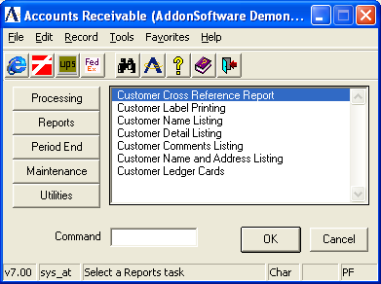
Accounts Receivable Reports Menu

Function
The reports and listings available to the Accounts Receivable module have all been gathered together in this task to make it easier for you to access them. Use this task when you want to print labels or ledger cards, etc., or to print customer information of several types.

n To access the Accounts Receivable Reports...

Select the Reports button after accessing Accounts Receivable.

About the Accounts Receivable Reports Menu
To print any report or listing on this menu, enter the number assigned to the task in the Enter An Option field.

Customer Cross-Reference Report
The Customer Cross-Reference Report task prints customer numbers and names in two sequences on the same page. The left column shows customers in number sequence. The right column shows customers listed in their alternate sequence, as defined by the Alt Seq field in the Customer Masterfile. Refer to Appendix A, page 5-10, for a sample copy of the printed report.

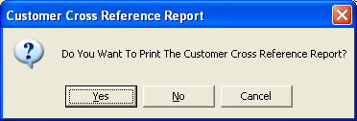

The following prompt is issued:

Do You Want To Print The Customer Cross Reference Report?

• Enter Y if you want to print the report.
-or-
Enter N to return to the Accounts Receivable Maintenance menu.

Printing
As the report prints, customer numbers are displayed on the screen to show its progress.

Customer Label Printing
The Customer Label Printing task prints mailing labels for each customer based on the options entered. The label format is adjustable and is specified in the Accounts Receivable parameters. Refer to Appendix A, page 5-11, for a sample copy of the printed labels.

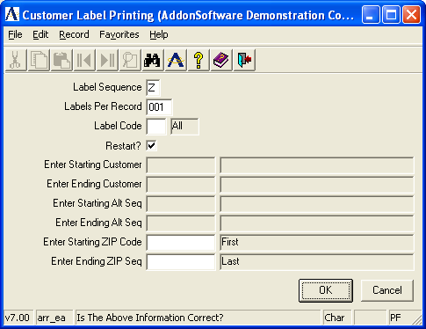

In the Label Seq field...
• Enter N to print labels in customer number sequence.
-or-
Enter A to print labels in customer alternate sequence.
-or-
Enter Z to print labels in customer zip code sequence.
-or-
Press F4 to return to the Accounts Receivable Reports Menu.

In the Labels Per Record field...
• Enter the number of labels you want to print for each customer record.

Example
When you select 6 labels per record and you have 100 customers, you will receive 6 labels for each customer for a total of 600 labels.

In the Label Code field...
• Enter a label code to print labels for customers with that code. The label code is set up for each customer in the Customer Maintenance task.
-or-
Press F3 to print labels for all customers in the selected sequence.

In the Restart field...
• Enter N to print all customer labels from the first through the last.
-or-
Enter Y to restart label printing by selecting a range of customers.

When you entered Y in the Restart field, the next two fields are activated.

Using the Graphical Interface:
- Click on the check box to indicate Yes, restart customer label printing.
-or-
Press Enter to leave blank and proceed to the next field.

In the Enter Beginning Info field...
• Enter the starting customer number, alternate sequence name or zip code (depending on Label Type). Labels will start printing from this information.
-or-
Press F1 to start with the first possible record.

In the Enter Ending Info field...
• Enter the customer number, alternate sequence name or zip code (depending on Label Type). Labels will print through this information.
-or-
Press F1 to end with the last possible record.

In the Enter Beginning Alt Seq field...
- Enter beginning alpha selection.
-or-
Press F1 for the first record.

In the Enter Ending Alt Seq field...
- Enter ending alternate sequence.
-or-
Press F1 for the last record.

In the Enter Beginning ZIP Code field...
- Enter starting ZIP code.
-or-
Press F1 for the first record.

In the Enter Ending ZIP Code field...
- Enter ending ZIP Code number.
-or-
Press F1 for the last record.

The following prompt is issued:

Is The Above Information Correct?

• Enter Y when all information is correct.
-or-
Enter N to return to the Label Sequence field.
-or-
Press F4 to return to the Accounts Receivable Reports Menu.

When you select Y to answer the prompt, another prompt is issued:

Do You Want To Print A Test Pattern?

• Enter Y to print a test pattern on the printer to assist in aligning the labels. You may print a test pattern as many times as is required to align the labels.
-or-
Enter N to start printing the labels without a test pattern.
-or-
Press F4 to return to the Accounts Receivable Reports Menu.

Printing
The customer number is displayed on the screen as the labels are printed.

Customer Name Listing
The Customer Name Listing task prints account numbers and names for customers by selected salesperson, territory, terms code, or customer type. Refer to Appendix A, page 5-13, to view sample copies.

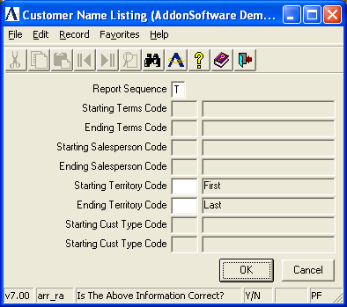

In the Report Sequence field...
• Enter M to print customer names by terms code.
-or-
Enter S to print names by salesperson code.
-or-
Enter T to print names by territory code.
-or-
Enter Y to print by customer type.
-or-
Press F4 to return to the Accounts Receivable Reports Menu.

In the Beginning Terms Code field...
• Enter the starting terms code, salesperson code or territory code (depending on Report Sequence). The report will start printing from this code.
-or-
Press F1 to start with the first possible code.

In the Ending Terms Code field...
• Enter the last terms code, salesperson code or territory code (depending on Report Sequence). The report will print through this code.
-or-
Press F1 to end with the last possible code.

In the Beginning Salesperson Code field...
- Enter beginning salesperson code.
-or-
Press F1 to begin with the first code on file.
-or-
Press F3 to select from the list of codes.

In the Ending Salesperson Code field...
- Enter ending salesperson code.
-or-
Press F1 to end with the last possible salesperson code.
-or-
Press F3 to select from the list of codes.

In the Beginning Territory Code field...
- Enter beginning territory code.
-or-
Press F1 to begin with the first territory code on file.
-or-
Press F3 to select from a list of codes.

In the Beginning Customer Type Code field...
- Enter the beginning customer type code.
-or-
Press F1 for the first possible customer type code.
-or-
Press F3 to select from the list of codes.

In the Ending Customer Type Code field...
- Enter the ending customer type code.
-or-
Press F1 for the last possible customer type code.
-or-
Press F3 to select from the list of codes.

The following prompt is issued:

Is The Above Information Correct?

• Enter Y when all information is correct.
-or-
Enter N to return to the Report Sequence field.
-or-
Press F4 to return to the Accounts Receivable Reports Menu.

Printing
The customer number is displayed on the screen as the report is printed.

Customer Detail Listing
The Customer Detail Listing task prints a detail listing of customer information for all customers. This task is used primarily to verify the information entered in the Customer Masterfile during the installation process. Refer to Appendix A, page 5-14, for a sample copy of the listing.

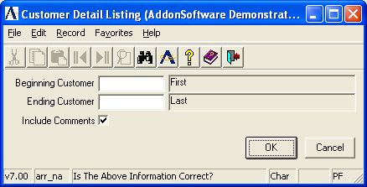

In the Beginning Customer field...
• Enter the beginning customer number.
-or-
Press F1 to select the first customer number on record.
-or-
Press F3 to select from a list of all valid customer numbers.

In the Ending Customer field...
• Enter the ending customer number.
-or-
Press F1 to select the last customer number on record.
-or-
Press F3 to select from a list of all valid customer numbers.

In the Include Comments field...
• Enter Y to include comments on the listing.
-or-
Enter N to print the listing without comments.

Using the Graphical Interface:
- Click on the check box to indicate Yes, include comments.
-or-
Press Enter to leave blank and proceed to the next field.

The following prompt is issued:

Is The Above Information Correct?

• Enter Y when the above information is correct and proceed with printing.
-or-
Enter N to make a change to the options.
-or-
Press F4 to return to the Accounts Receivable Reports Menu.

Printing
The customer numbers is displayed on the screen as the listing is printed.

Customer Comments Listing
The Customer Comments Listing task prints customer comments as set up in the Customer Maintenance task, selected by salesperson or territory. Refer to Appendix A, page 5-15, for a sample copy of the listing.

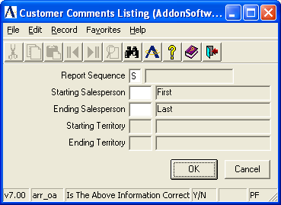

In the Report Sequence field...
• Enter S to print customer comments by salesperson code.
-or-
Enter T to print customer comments by territory code.
-or-
Press F4 to return to the Accounts Receivable Reports Menu.

In the Beginning Salesperson Code field...
• Enter the beginning salesperson code or territory code (depending on Report Sequence). The report will start printing from this code.
-or-
Press F1 to begin with the first possible code.
-or-
Press F3 to select from a list of all valid codes.

In the Ending Salesperson Code field...
• Enter the last salesperson code or territory code (depending on Report Sequence).
-or-
Press F1 to end with the last possible code.
-or-
Press F3 to select from a list of all valid codes.

In the Beginning Territory Code field...
- Enter the first territory code on file.
-or-
Press F1 to begin with the first possible code.
-or-
Press F3 to select from a list of all valid codes.

In the Ending Territory Code field...
- Enter the last territory code on file.
-or-
Press F1 to end with the last possible code.
-or
Press F3 to select from a list of all valid codes.

The following prompt is issued:

Is The Above Information Correct?

• Enter Y when the above information is correct and proceed with the listing.
-or-
Enter N to make a change to the options.
-or-
Press F4 to return to the Accounts Receivable Reports Menu.

Printing
The customer number is displayed on the screen as the report is printed.

Customer Name and Address Listing
The Customer Name and Address Listing task prints an alphabetic or numeric listing of all customer names, addresses and telephone numbers. Refer to Appendix A, page 5-16, for a sample copy of the printed listing.

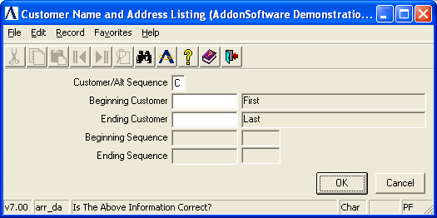

In the Customer/Alt Sequence field...
• Enter C to print the report in customer number sequence.
-or-
Enter A to print the report by alternate sequence.

In the Beginning Customer field...
• Enter the customer number/alternate selection with which to start the report.
-or-
Press F1 to start with the first customer number/alpha selection on file.
-or-
Press F3 to select from a list of all valid customers.

In the Ending Customer field...
• Enter the customer number/alpha selection with which to end the report.
-or-
Press F1 to end with the last customer number/alpha selection on file.
-or-
Press F3 to select from a list of all valid customers.

In the Beginning Sequence Code field...
- Enter beginning sequence code.
-or-
Press F1 to begin with the first code on file.
-or-
Press F3 to select from a list of valid codes.

In the Ending Sequence Code field...
- Enter the ending sequence code.
-or-
Press F1 to end with the last code on file.
-or-
Press F3 to select from a list of valid codes.

The following prompt is issued:

Is The Above Information Correct?

• Enter Y to print the report.
-or-
Enter N to change any of the report options.
-or-
Press F4 to return to the Accounts Receivable Reports Menu.

Customer Ledger Card Listing
The Customer Ledger Card Listing task lists all outstanding invoices, up to a selected date, for a range of customers. The information shown includes invoice number, date, date due, invoice amount, amount applied and invoice balance. Refer to Appendix A, page 5-17, for a sample copy of the printed cards.

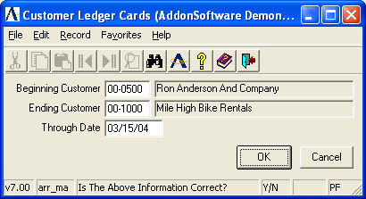

In the Beginning Customer field...
• Enter the number of the first customer for which a ledger card is desired.
-or-
Press F1 to begin with the first customer on file.
-or-
Press F3 to select from a list of all valid customers.
-or-
Press F4 to return to the Accounts Receivable Report Menu.

In the Ending Customer field...
• Enter the number of the last customer for which a ledger card is desired.
-or-
Press F1 to end with the last customer on file.
-or-
Press F3 to select from a list of all valid customers.

In the Through Date field...
• Enter the date through which transactions should be included.
-or-
Press Return to use the terminal date.

Period-End Processing
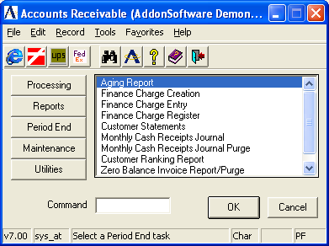
AR Period-End Processing Menu

Function
The Period-End Processing menu provides access to the tasks that are part of the accounts receivable period-end process. Other than the Period-End Update task itself, any of these selections may be run on demand at any time.

Shown above is the menu as it exists for the standard software. Your module may show a different list of tasks, depending on how it was installed or the custom changes that were made.

n To access the Period-End Processing menu...

Select Period End button after accessing Accounts Receivable.

About the Period-End Processing Tasks
To access any task on this menu, enter the number assigned to the task in the Enter An Option field.

Aging Report
The Period-End Processing Aging Report is exactly the same as that which is documented as part of the Accounts Receivable main menu in the previous Aging Report section (page 4-24). It appears on both the main menu and the period end menu solely for the convenience of the operator.

Finance Charge Creation
The Finance Charge Creation task automatically creates finance charge invoices for customers based on days overdue, invoice amount, finance charge rate and minimum finance charge amount. This is the first step of applying finance charges to customer accounts, followed by the printing of the Finance Charge Register and the update. Finance charges for individual customers may also be entered or modified using the Finance Charge Entry task.

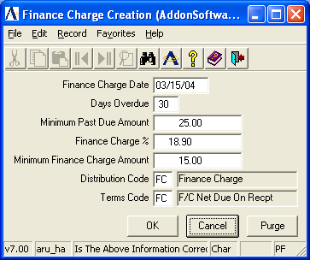

In the Date field...
• Enter a valid date.
-or-
Press F4 to return to the Period-End Processing Menu.

This date is the accounting date of the finance charge. The due date and days overdue are calculated using this date as a base and the assigned terms code.

In the Days Overdue field...
• Enter the number of days that an invoice must be overdue in order to have finance charges applied.

The days overdue are calculated from the finance charge date entered in the Date field. Open invoices dated on or before this date are considered for finance charges.

Example
For instance, when the finance charge date is 12/30/04 and the days overdue is 60, only open invoices with due dates on or before 10/31/04 are considered for finance charge calculation.

In the Minimum Invoice Amount field...
• Enter the minimum dollar amount for an invoice to be considered for finance charge calculation.

Example
Enter 10.00 to consider invoices which are $10.00 or greater for finance charges.

In the Finance Charge % field...
• Enter the percentage rate to be used in finance charge calculation.

This is the percentage rate that applies to this particular application of the finance charge.

Example
Enter 1.25 to calculate finance charges of 1.25% (.0125). When an overdue invoice is $150 and the finance charge percent is 1.25, the amount of the finance charge is $1.88.

In the Minimum Finance Charge Amount field...
• Enter the smallest finance charge amount that is to be applied to an invoice.

When a calculated finance charge is smaller than this amount, it is replaced with the minimum finance charge amount. In other words, whenever a finance charge is applied, it is this amount or greater.

Example
When you enter 1.00, finance charges less than $1.00 are not applied to eligible invoices.

In the Distribution Code field...
• Enter a valid general ledger distribution code.
-or-
Press F3 to select from a list of all valid distribution codes.

This code will determine the general ledger postings for the accounts receivable and finance charge revenue accounts, when selected as part of the update process.

In the Terms Code field...
• Enter a valid terms code.
-or-
Press F3 to select from a list of all valid terms codes.

This code will determine the due date of the finance charge based on the finance charge date.

The following prompt is issued:

Is The Above Information Correct?

• Enter Yes when the above information is correct.
-or-
Enter No to make a change to the selections.
-or-
Enter Purge to clear all previously created finance charges that have not been updated.
-or-
Press F4 to return to the menu.

Processing
The task will search through all open accounts receivable invoices. The invoice number being examined is displayed on the screen. When the invoice is overdue, the balance is checked for minimum size. If the balance is large enough, the finance charge amount is calculated. When the finance charge amount is large enough, a finance charge record is created.

NOTE: Finance charges generated through this process may be modified or deleted using the Finance Charge Entry task prior to updating the Finance Charge Register.

Finance Charge Entry
The Finance Charge Entry task allows you to enter finance charges for individual customers or modify finance charges automatically created by the Finance Charge Creation task. This task may be run after reviewing the Finance Charge Register in order to adjust the finance charges for specific customers.

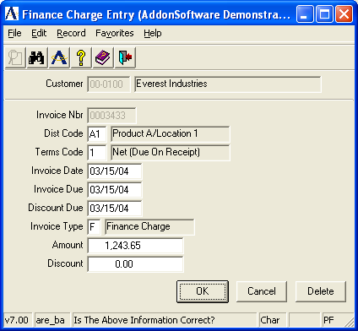

NOTE: This task is the same as the Conversion Invoice Entry task, and uses the same data entry file. Therefore, care should be taken to separate the Finance Charge Entry process from the Conversion Invoice Entry process.

In the Customer Number field...
• Enter a valid customer number. The associated customer name also appears automatically.
-or-
Press F3 to select from a list of all valid customer numbers.
-or-
Press F4 to return to the menu.

In the Invoice Number field...
• Enter a seven-digit invoice number that is used to identify the finance charge transaction.

When the invoice has already been updated to the Accounts Receivable Open Invoice file, you will not be able to enter the transaction. To adjust invoices, refer to the Cash Receipts Entry or Simple Invoice Entry tasks.

In the Distribution Code field...
• Enter a valid distribution code. The description of the code is displayed.
-or-
Press Return to accept the code associated with the customer. (Refer to the Customer Maintenance task in the Accounts Receivable Maintenance section.)
-or-
Press F3 to select from a list of all valid distribution codes.

The distribution code determines the general ledger account numbers for finance charge revenue, accounts receivable and discounts when the finance charge is updated.

NOTE: You may want to define a distribution code called FC just for finance charges. Refer to the Distribution Code Maintenance task for more information.

In the Terms Code field...
• Enter a valid terms code. The description of the code is displayed.
-or-
Press Return to use the default terms code associated with the customer. (Refer to the Customer Maintenance task in the Accounts Receivable Maintenance section.)
-or-
Press F3 to select from a list of all valid terms.

The terms code will determine the due date and discount due date for the finance charge, using the invoice date as a reference point. Normally, finance charges are set up with terms code of net or due on receipt.

In the Invoice Date field...
• Enter the date that the finance charge is to be posted to general ledger.

This date is used as the reference point by the terms code to determine the due date and discount due date of the finance charge. These dates are displayed and may be overridden if desired.

In the Invoice Due field...
• Enter the date that the finance charge is due.
-or-
Press Return to accept the default.

In the Discount Due field...
• Enter the date through which the customer may take the discount.
-or-
Press Return to accept the default.

Discounts are not generally offered on finance charges.

In the Invoice Type field...
• Enter F when the transaction is a finance charge.

In the Amount field...
• Enter the total amount of the finance charge.

When adjusting a finance charge that was generated automatically by the Finance Charge Creation task, this becomes the new amount.

In the Discount field...
• Enter the amount of discount available on this finance charge, if applicable.

NOTE: Discounts are recorded as memo amounts only at this point. They are not posted to general ledger until after they are actually taken. This is determined during cash receipts processing.

The following prompt is issued:

Is The Above Information Correct?

• Enter Y when the above information is correct.
-or-
Enter N to make a change to the entry.
-or-
Enter Delete to erase the finance charge from the data entry file.

Finance Charge Register
The Finance Charge Register task prints a report of all calculated finance charges prior to making postings to the customers’ accounts. Included are all finance charges automatically created by the Finance Charge Creation task and manually entered through the Finance Charge Entry task. Finance charges may be optionally posted to the general ledger. Refer to Appendix A, page 5-18, for a sample copy of the printed register.
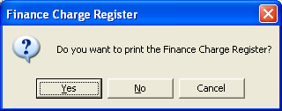

NOTE: Because the Finance Charge Register is printed from the same file as that used by the Conversion Invoice Register, each of these processes should be run separately to avoid confusion between them.

The following prompt is issued:

Do You Want To Print The Finance Charge Register?

• Enter Yes to print the register.
-or-
Enter No to return to the menu without printing.

NOTE: Any finance charge that is automatically generated through the Finance Charge Creation task may be modified or deleted using the Finance Charge Entry task prior to updating the Finance Charge Register.

Do You Want To Update The General Ledger From This Register?

• Enter Yes to update the general ledger. A general ledger summary page will print for your inspection. You must also update the Finance charge Register in order for the general ledger postings to take place.
-or-
Enter No, if you do not want to post transactions to the general ledger but still have them added to the customer’s open invoice files when the Finance Charge Register is updated.
-or-
Press F4 to return to the menu without updating anything.

Printing
The customer numbers are displayed on the screen as the register is printed. After printing and inspecting the register, you may choose whether or not to update the selection when the system issues this prompt:

Are You Ready To Update The Finance Charge Register?

• Enter Yes to post the result of the finance charge calculation to the customer’s AR Open Item files and create general ledger postings.
-or-
Enter No to return to the AR Period-End Processing Menu without updating. Transactions will remain unposted in the AR open invoice file until the Finance Charge Register is updated.

Updating
The finance charges are posted to the customers’ accounts. When the option is selected to post to general ledger and the Finance Charge Register is also updated, the amount of the finance charge is debited to the accounts receivable account and credited to the revenue account. The accounts set up for the finance charge distribution code in the Accounts Receivable Distribution Code Maintenance task will be used.

Where individual finance charges are entered using the Finance Charge Entry task, the distribution code established for each of those entries is used.

Customer Statements
The Customer Statements task selects and prints customer statements. Statements may be printed only for those customers who have the Statements field set to Y in the Customer Masterfile. Zero and credit balance statements are not printed, nor are the paid invoices from prior months. An additional selection criterion is provided and the statements may be restarted in the event of a paper jam or printer malfunction. Refer to Appendix A, page 5-19, for a sample copy of the printed statements.

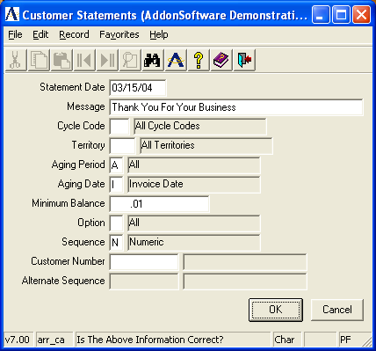

In the Statement Date field...
• Enter the date that will serve as the cutoff date for all transactions that are to appear on the statement. This date also serves as the reference date for calculating the Aging Summary printed at the bottom of the statement.
-or-
Press Return to default to the terminal date.
-or-
Press F4 to return to the menu.

In the Message field...
• Enter up to 40 characters of a general message to print on each statement.

Messages are usually used for holiday greetings or for changes in company billing policies, special notes, etc.

In the Cycle Code field...
• Enter the cycle code for this statement run.
-or-
Press F1 to select all codes.
-or-
Press F3 to select from a list of all valid codes.

In the Territory field...
• Enter a valid territory code.
-or-
Press F1 to select all territories.
-or-
Press F3 to select from a list of all valid codes.

In the Aging Period field...
• Enter A to print statements for all customers who have an accounts receivable balance.
-or-
Enter 1 to include customers who have accounts receivable balances of 30 days and older.
-or-
Enter 2 to only include customers who have a balance of 60 days and older.
-or-
Enter 3 to only include customers who have a balance of 90 days and older.
-or-
Enter 4 to only include customers who have a balance of 120 days and older.

In the Aging Date Or Invoice Date field...
• Enter D to calculate the invoice aging by due date.
-or-
Enter I to calculate the invoice aging by invoice date.

In the Minimum Balance field...
• Enter the aging minimum balance for which statements are printed.
Statements will not be printed for aging balances less than this amount.

In the Option field...
• Press F1 to print statements for all customers who meet the selected criteria.
-or-
Enter R to restart with a selected customer and print through the end.
-or-
Enter S to print a statement for one customer only.

In the Alternate Sequence field...
• Enter A to print the statements in alternate sequence order.
-or-
Enter N to print the statements in numerical order.

This field defaults to numeric order when printing only one customer statement.

In the Customer Number field...
This field is not available if All was selected in the Option field.
When statements are to be printed in numeric order:
• Enter a valid customer number.
-or-
Press F3 to select from a list of all valid numbers.

In the Alternate Sequence field...
When statements are to be printed in sequence:
• Enter the letter of the alphabet from where the printing is to begin.

This field is used to tell the system where to restart a print job that is interrupted for any reason.

The following prompt is issued:

Is The Above Information Correct?

• Enter Y when the information is correct.
-or-
Enter N to make a change to the options.
-or-
Press F4 to return to the menu.

When you enter Y to the previous prompt, the system issues another:

Do You Want To Print A Test Pattern?

• Enter Y to print a test pattern on the printer to assist in aligning the forms. You can run the test as many times as needed.
-or-
Enter N to start printing the statements.
-or-
Press F4 to return to the menu.

Printing
The customer number is displayed on the screen when statements are printed in numeric order. The customer alternate sequence is displayed when printing by alpha sequence.

Monthly Cash Receipts Journal
The Monthly Cash Receipts Journal task prints a detailed report of selected cash receipts in customer number sequence for a selected time period. A general ledger recap of all transactions is available. Refer to Appendix A, pages 5-20 and 5-21, for a sample copy of the printed journal.

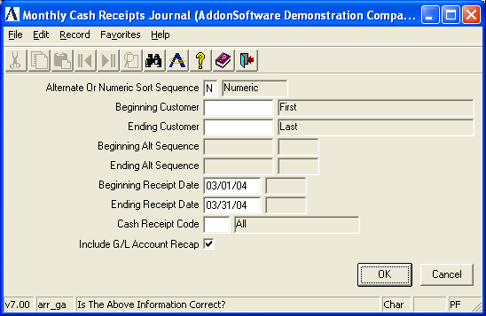

In the Alt Or Numeric Sort Sequence field...
• Enter A to print the journal by alternate sequence.
-or-
Enter N to print the journal by customer number.

In the Beginning Customer field...
• Enter a valid customer number.
-or-
Press F1 to select the first customer number on file.
-or-
Press F3 to select from a list of all valid customers numbers.

In the Ending Customer field...
• Enter a valid customer number.
-or-
Press F1 to select the last customer number on file.
-or-
Press F3 to select from a list of all valid customer numbers.

In the Beginning Alt Sequence field...
Enter a number representing an alternate sequence of customer numbers.
-or-
Press F1 to begin with the first customer number on file.

In the Ending Alt Sequence field...
• Enter a number representing the end of an alternate sequence of customer numbers.
-or-
Press F1 to end with the last customer number on file.

In the Beginning Receipt Date field...
• Enter the receipt date from which you want to start printing the Cash Receipts Journal.
-or-
Press F1 to start with the first possible date.

In the Ending Receipt Date field...
• Enter the receipt date through which you will include invoices on the Cash Receipts Journal.
-or-
Press F1 to end with the last possible date.

In the Cash Receipt Code field...
• Enter a valid cash receipt code.
-or-
Press F1 to select all codes.
-or-
Press F3 to select from a list of all valid codes.

In the Include GL Account Recap field...
• Enter Y to include an account recap on the journal.
-or-
Enter N to print the journal without an account recap.

Using the Graphical Interface:
- Click on the check box to indicate Yes, include GL Account Recap on the report.
-or-
Press Enter to leave blank and proceed to the next field.

The following prompt is issued:

Is The Above Information Correct?

• Enter Y to print the journal.
-or-
Enter N to change options.
-or-
Press F4 to return to the menu.

Printing
As the journal is printed, its progress is displayed on the screen.

Monthly Cash Receipts Journal Purge
The Monthly Cash Receipts Journal Purge task clears the Monthly Cash Receipts Journal as of a specified date. The journal file may contain a record of cash receipts for several months. Periodically, it should be reviewed and cleared if the size of the file becomes excessive.

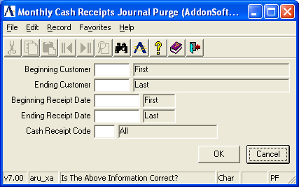

NOTE: If required, make certain you have printed a copy of the Monthly Cash Receipts Journal before running the purge.

In the Beginning Customer field...
• Enter a valid customer number.
-or-
Press F1 to select the first number on record.
-or-
Press F3 to select from a list of all valid customer numbers.

In the Ending Customer field...
• Enter a valid customer number.
-or-
Press F1 to select the last customer number on record.
-or-
Press F3 to select from a list of all valid customer numbers.

In the Beginning Receipt Date field...
• Enter the starting date of the receipts to be purged.
-or-
Press F1 to select the first date on record.

In the Ending Receipt Date field...
• Enter the last date of the receipts to be purged.
-or-
Press F1 to select the last date on record.

In the Cash Receipt Code field...
Enter a valid cash receipt code.
-or-
Press F1 to select all codes.
-or-
Press F3 to select from a list of all valid codes.

The following prompt is issued:

Is The Above Information Correct?

Enter Yes to remove all receipts through the purge date.
-or-
Enter No if the purge date is incorrect and make a change.
-or-
Press F4 to return to the menu.

Processing
As the receipts are removed from the journal, progress is displayed on the screen.

Customer Ranking Report
The Customer Ranking Report task prints a report showing sales to and profits from all customers, ranked by month-to-date or year-to-date sales, profit or profit as a percent of sales. A customer number sort is also available (not ranked) and ranking by territory code, salesperson code or customer type may be selected for any report. Refer to Appendix A, page 5-22, for a sample copy of the printed report.

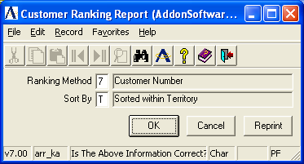

NOTE: The sales and profit information shown on each Customer Ranking Report is derived from the aging and sales data. It includes Simple Invoices (which include no costs) and type “O” line items as well as standard sales data.

In the Ranking Method field...
• Enter a number from the list below that represents the type of ranking for the report.
-or-
Press F4 to return to the Period-End Processing Menu.

1 = MTD Sales (Month-to-date gross dollar sales)
2 = MTD GP (Month-to-date gross profit)
3 = MTD % (Month-to-date profit as a percentage of gross sales)
4 = YTD Sales (Year-to-date gross dollar sales)
5 = YTD GP (Year-to-date gross profit)
6 = YTD % (Year-to-date profit as a percentage of gross sales)
7 = CUST (Customer number)

In the Sort by Territory/Salesperson/Type/None field...
• Enter a letter from the list below that represents how the customer information is ranked.

S = Salesperson code
T = Territory code
Y = Type code
N = None; entire customer file is on report
The following prompt is issued:

Is The Above Information Correct?

• Enter Y when your selections are correct and you want to rebuild the data file.
-or-
Enter N to change your selections.
-or-
Enter R to print the report with this ranking using data from your last rebuild.
-or-
Press F4 to return to the Period-End Processing Menu.

Zero Balance Invoice Report and Purge
Based on an operator entered date, this task reads through the Accounts Receivable Open Invoice file and prints a report showing all invoices with a zero balance prior to purging. This task should be run as required to keep the open invoice file to a manageable size. Refer to Appendix A, page 5-23, for a sample copy of the printed report.

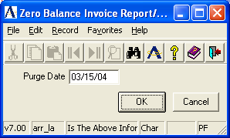

CAUTION: This task provides the capability to purge zero balance invoices as of any date. If you want to print customer statements showing payments made during the current month, do so before purging the current month’s activity.

In the Purge Date field...
• Enter the date through which all zero balance invoices are removed from the accounts receivable open invoice file.
-or-
Press F4 to return to the menu.

The following prompt is issued:

Is The Above Information Correct?

• Enter Yes to print a report showing all zero-balance invoices through the purge date.
-or-
Enter No when the purge date is incorrect.
-or-
Press F4 to return to the Period-End Processing Menu.

Printing
As the invoices are printed, progress is displayed on the screen.

When the invoices are printed, the following prompt is issued:

Are You Ready To Purge These Invoices?

• Enter Yes to purge the invoices shown on the register.
-or-
Enter No to return to the Period-End Processing Menu.

Updating
As the invoices are purged, progress is displayed on the screen. The invoice records including all related payments, and adjustment records are deleted from the file.

Period-End Update
The Period-End Update closes the accounting period for the Accounts Receivable module. This process also initializes Sales Analysis for the next year when it runs for the last period of the fiscal year.

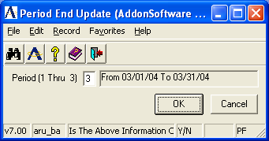

In the Period <1 Thru XX/End> field...
Where XX equals the current period
• Enter a valid fiscal period from 1 through the last number shown on the screen.
-or-
Press F4 to return to the menu.

CAUTION: Be sure you have reviewed the steps required for period-end processing as outlined in the Flow of Processing section of this manual before proceeding with the update.

The following prompt is issued:

Is This The Correct Period?

• Enter Yes to begin the update.
-or-
Enter No to select another period.

Updating
The update performs the following tasks:

1. The month-to-date sales and cost-of-sales figures in the Customer Masterfile are reset to zero. For the last period in the fiscal year, the year-to-date figures are moved to the prior year and the current year figures are set to zero.

2. Month-to-date sales register totals are cleared.

3. Month-to-date cash receipts totals are cleared.

4. Temporary customers (those with Retain set to N in their Customer Masterfile) not having any open invoices or credit balances are removed.

5. The current period indicator in the Accounts Receivable parameters is incremented. For the last period of the fiscal year, the current year indicator is incremented and the current period indicator is set to 1.

6. For the last period of the fiscal year, the Sales Analysis module’s files are initialized for the new year.

Accounts Receivable Maintenance
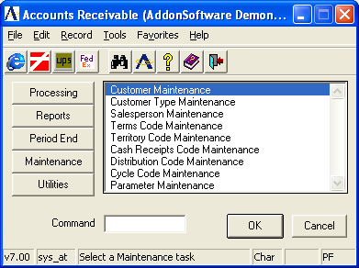
Accounts Receivable Maintenance Menu

Function
The Accounts Receivable Maintenance Menu provides access to the Customer Masterfile as well as the supporting codes used throughout the module. Maintenance of the Accounts Receivable parameters is also performed through this menu.

Shown above is the menu as it exists for the standard software. Your module may show a different list of tasks or the custom changes that were made depending on how it was installed.

n To access the Accounts Receivable Maintenance menu...

Select the Maintenance button after accessing Accounts Receivable.

About the Accounts Receivable Maintenance Menu Tasks
To access any task on this menu, enter the number assigned to the task in the Enter An Option field.

Customer Maintenance
The Customer Maintenance task allows for the entry of new customers, maintenance of existing customers and access to the customer’s status and history.

When you first access this task, the cursor appears in the Customer No field. Refer to Customer Number, in Customer Maintenance for information on entering a customer number.

The Customer Maintenance Options menu is displayed on the screen when a customer is selected for maintenance. Changes can only be made to the customer’s records by selecting options from this menu.

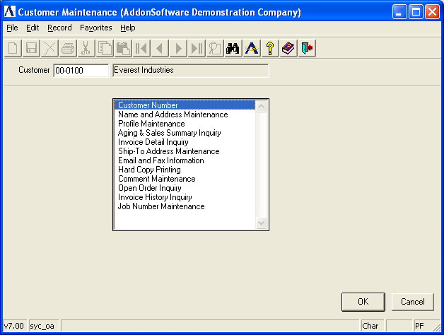

About the Customer Maintenance Options
The Customer Maintenance Options menu allows you to work on one customer after another without ever leaving the Customer Maintenance task. Once a customer record is accessed, you can make adjustments. When you select an option from the menu, the list of options disappears from the screen and the selected option’s field prompts requiring your attention appear at the bottom of the screen. After you have entered and accepted the changes, the menu will once again be displayed.

Customer Number
Selecting this option returns you to the Customer No field where you can access one customer after another without leaving the Customer Maintenance task.

In the Customer No field...
• Enter the customer number.
-or-
Press F2 to accept the next customer on file. (Refer to Automatic Customer Numbering, below.)
-or-
Press F3 to select from a list of all valid customers.
-or-
Press F4 to return to the Accounts Receivable Maintenance menu.

When you enter a number that does not exist in the system, the following prompt is issued:

Is This A New Record?

• Enter N to return to the Customer No field and select another customer number.
-or-
Enter Y to set up a new customer with this number. The system will advance to the Name field.

In the Name field...
• Enter the name of the customer. The Name, Address & Profile option is displayed. (Refer to Name, Address & Profile, in the following section.)

NOTE: To delete a customer, select the Name, Address and Profile option and type Delete in response to the prompt at the bottom of the screen. A customer may not be deleted if an accounts receivable balance exists.

Automatic Customer Numbering
Optional
The Accounts Receivable module can provide for automatic sequential numbering for new customers. This offers a fast, controlled method of assigning numbers for new customers, as in the initial download to the computer.

Setting the Automatic Customer Numbers parameter to Y in the Accounts Receivable Parameter Maintenance task activates this option. When the automatic numbering feature is activated, you may still assign your own customer numbers as required. This automatic sequencing option is not available for alpha-numeric codes.

Name, Address & Profile Maintenance
The Name, Address & Profile option allows for the inquiry and change of the customer name and address, along with other information used by the Accounts Receivable and Order/Invoice Processing modules. It is also the option to use in removing customers from your system.

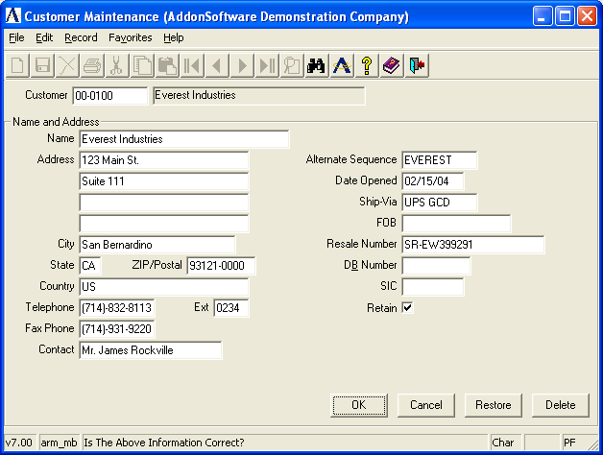

When entering a new customer, the fields in this option are blank. When an existing customer is accessed, all address information is displayed.

In the Name field...
• Enter a customer name of up to 30 characters.

In the Address field...
• Enter up to five lines (24 characters each) of customer address information.

In the City field...
- Enter up to 22 characters to identify the name of the city associated with the customer.

In the State field...
- Enter 2 characters to identify the name of the state associated with the customer.

In the Zip/Postal field...
• Enter the customer’s zip code.

Either a 5 or 9 digit zip code is requested, depending on how the parameter is set in Accounts Receivable Parameter Maintenance.

In the Country field...
• Enter up to 24 characters representing the name of the country associated with the customer.

In the Telephone field...
• Enter the customer’s telephone number with area code.

The punctuation for the area code and prefix are displayed automatically.

In the Ext field...
• Enter a telephone extension number, if applicable.

In the Fax Phone field...
- Enter a fax phone number , if applicable.

In the Contact field...
• Enter the name of the customer’s contact person up to 20 characters in length.

The first 10 characters in this name are used for searches of contacts made by the F3=Lookup key.

In the Alt Seq field...
• Enter an alternate sequence for the customer up to 10 characters in length.
-or-
Press F1 to use the last name of the customer.
-or-
Press Return to accept the default of the first 10 characters of the customer name.

When using the F3=Lookup function key, this sequence is used to locate the customer by name. It is also used to sort customers alphabetically for reports. Generally, it is made up of the first 10 characters of the name; however, any name can be entered. For instance, you may want to enter AT&T for American Telephone and Telegraph.

In the Date Opened field...
• Enter the date that this customer was originally established.
-or-
Press Return to accept the terminal date.

This date can also be used to record when the customer was set up on the computer.

In the Ship-Via field...
• Enter the standard shipping method for this customer, up to 10 characters in length.
-or-
Press F3 to select from a list of all valid shipping types if the SpeedShip module is installed on your system.

This becomes the default value used by the Order/Invoice Processing module.

In the FOB field...
- Enter up to 15 characters to identify the freight charge description.

In the Resale No field...
• Enter the customer’s resale identification number, if applicable.

In the D&B Number field…
- Enter the customer’s Dun & Bradstreet identification number.

In the SIC Code field…
- Enter the Standard Industry Code classification number for the customer.

In the Retain field...
• Enter N to remove this customer during period-end processing when invoices do not exist.
-or-
Enter Y to retain this customer during the accounts receivable period-end processing, when the customer’s accounts receivable balance is zero.

Using the Graphical Interface:
- Click on the check box to indicate Yes, retain this customer.
-or-
Press Enter to leave blank and proceed to the next field.

The following prompt is issued:

Is The Above Information Correct?

• Enter Y to access the profile information on this customer.
-or-
Enter N to update the customer name and to access the address fields.
-or-
Enter a two-digit number to position the cursor at a specific field (i.e. type 10 to go to the tenth field or 5 to move to the fifth).
-or-
Enter Restore to undo any changes you have made since entering this option.
-or-
Enter Delete to remove the customer from the system. When any outstanding accounts receivable balance exists for the customer, the deletion request is ignored.

Profile Information
In addition to the standard name and address information, there are a number of file-verified fields that may be associated with a customer. These codes are generally used throughout the Order/Invoice Processing and Sales Analysis modules. During Order/Invoice Entry, they provide default values that speed the data entry process. The default values may always be overridden for a particular order or invoice.

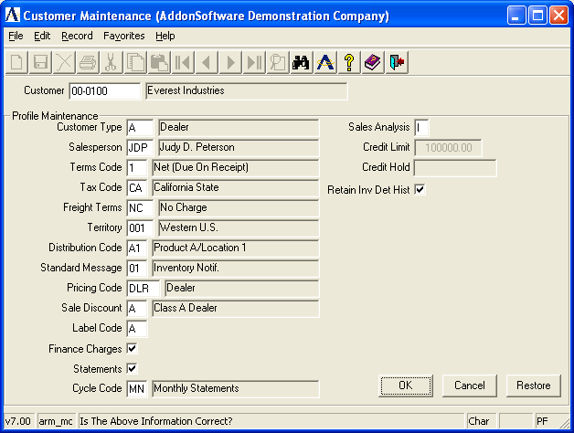

Not all of these fields may be applicable to your business (such as the Territory). However, you still must assign a code when setting up a customer. When this is the case, establish a single code (i.e., one named “Standard”) to apply to the entire customer base and enter that code for each customer.

You may also find that a file-verified field, when taken literally, may be used for another purpose depending on how it was installed. Study each of these codes and how they effect the module operation before you rule out their use. Familiarity with Order/Invoice Processing and Sales Analysis is helpful in making these determinations.

Example
The Territory Code provides a way to track customer sales by geographic location in the Sales Analysis module. When it is not applicable to your business, you may use the code to track sales by another category, such as customer account type (i.e. wholesale vs. retail).

In the Customer Type field...
• Enter a valid customer type as defined in the Customer Type Maintenance task.
-or-
Press F3 to select from a list of all valid types.

The customer type is used for sales analysis purposes. Each customer must be assigned a customer type, even when all customers are set up to be the same type.

In the Slsprsn No field...
• Enter a valid salesperson code as defined in the Salesperson Maintenance task.
-or-
Press F3 to select from a list of all valid salespersons.

The salesperson is used for reporting in this module and in the Order/Invoice Processing and Sales Analysis modules.

In the Terms Code field...
• Enter a valid terms code as defined in the Terms Code Maintenance task.
-or-
Press F3 to select from a list of all valid terms codes.

In the Tax Code field...
• Enter a valid sales tax code for the customer that is used by the Order/Invoice Processing module.
-or-
Press F3 to select from a list of all valid codes.

You must enter a tax code even when the customer is reselling merchandise. In this case, you should have a tax code with a zero percent and description of “Resale” or “Non-Taxable.”

Keep in mind that the tax code only specifies the tax jurisdiction for the customer. The actual application of sales tax during the Order/Invoice Entry process is also determined by the item being sold and order line type that have their own definition of taxability.

In the Freight Terms field...
- Enter a valid freight terms code.
-or
Press F3 to select from a list of valid codes.

In the Territory field...
• Enter a valid territory code as defined in the Territory Code Maintenance task.
-or-
Press F3 to select from a list of all valid territory codes.

In the Dist Code field...
• Enter a valid distribution code.
-or-
Press F3 to select from a list of all valid distribution codes.

The distribution code provides the capability to associate a different account for receivable, sales tax, freight and optionally revenue, for each customer.

In the Cycle Code field...
• Enter a valid cycle code that determines when this customer will receive a statement.
-or-
Press F3 to select from a list of all valid codes.

In the Std Message field...
• Enter an optional standard message code that will appear on the customer’s invoice.
-or-
Press F3 to select from a list of all valid messages.

In the Pricing Code field...
• Enter a valid price code as defined in the Price Code Maintenance task.
-or-
Press F1 for none.
-or-
Press F3 to select from a list of all valid price codes.

The customer pricing code, in conjunction with an inventory item class code, identifies a quantity break table that is used to calculate prices during order and invoice entry.

When the Order/Invoice Processing module is not installed, this field is not applicable and may be left blank.

In the Sales Discount field...
• Enter a valid sales discount code as defined in the Sales Discount Code Maintenance task.
-or-
Press F3 to select from a list of all valid discounts.

The sales discount code allows you to provide a percentage discount on a customer’s entire invoice as entered through the Order/Invoice Processing module.

The sales discount is separate from the pricing method used to calculate sales prices on inventory items during the Order/Invoice Entry process.

In the Label Code field...
• Enter a two-character code used for selection purposes during Customer Label printing.

In the Finance Charge field...
• Enter Y if the customer is eligible for finance charges.
-or-
Enter N if this customer is not eligible for finance charges.

Finance charge calculations are made as a separate process, depending on a number of other accounts receivable criteria.

Using the Graphical Interface:
- Click on the check box to indicate Yes, include finance charges.
-or-
Press Enter to leave blank and proceed to the next field.

In the Statements field...
• Enter Y when this customer is eligible to receive accounts receivable statements.
-or-
Enter N when the customer is not to receive statements.

Other selection criterion is available at the time the statements are actually printed.

Using the Graphical Interface:
- Click on the check box to indicate Yes, include finance charges.
-or-
Press Enter to leave blank and proceed to the next field.

In the Cycle Code field...
- Enter the cycle code for this customer.
-or-
Press F1 to select all codes.
-or-
Press F3 to select from a list of all valid codes.

In the Sales Analysis field...
• Enter P to summarize sales analysis for this customer on a product code level.
-or-
Enter I to retain sales analysis for this customer by inventory item (most detailed).
-or-
Enter N to not collect sales analysis data for this customer.

When the Sales Analysis module is installed, this field controls how sales analysis data is collected for this customer. However, the level of sales analysis detail is limited by the settings created in Sales Analysis Parameter Maintenance.

In the Credit Limit field...
This field is only accessible if Credit Management is not installed.
• Enter the maximum amount of credit to be extended this customer before a hold is placed on their account.

When Credit Management is installed, this field shows the credit limit placed on this customer in the Credit Manager’s Review & Release task in Order/Invoice Processing.

In the Credit Hold field...
This field is display only and appears only if the Credit Management system is installed.

A customer may be placed on credit hold for one of several reasons, depending partly on the setting of the Credit Management parameters. Credit holds may be placed automatically on any new customer or on one who has exceeded a credit limit. The credit manager may also manually apply a credit hold. Refer to Credit Management Parameters in the Installation section of the Order/Invoice Processing manual for further information.

In the Retain Detail History field...
• Enter Y for each customer for whom invoice history is to be retained.
-or-
Enter N for each customer for whom invoice history is not to be retained.

Using the Graphical Interface:
- Click on the check box to indicate Yes, retain detail history.
-or-
Press Enter to leave blank and proceed to the next field.

The following prompt is issued:

Is The Above Information Correct?

• Enter Y to update the customer profile record and return to the Option Menu.
-or-
Enter N to access the profile fields.
-or-
Enter a two-digit number to position the cursor at a specific field (i.e. type 10 to go to the tenth field, or 5 to move to the fifth).
-or-
Enter Restore to undo any changes you have made since entering this option.

Aging and Sales Summary
The Aging and Sales Summary option provides on-line inquiry into a customer’s accounts receivable balance, summarized aging, average days to pay and summarized sales and gross profit information. All fields are display only.

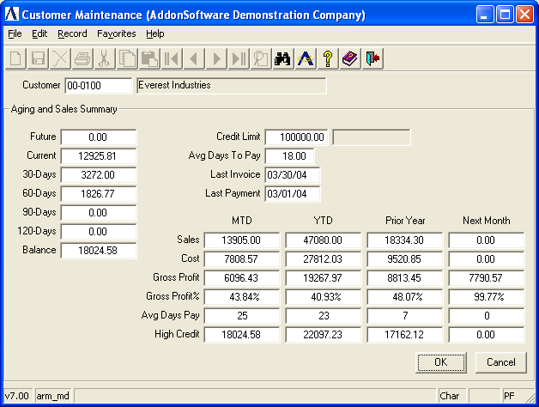

In the Future field...
Shows the amount of a customer’s open invoices with a due date beyond the current period. An amount will normally appear in the future if it is not yet due.

In the Current field...
Shows the amount of a customer’s open invoices with a due date from present to 29 days past due.
In the 30-days field...
Shows the amount of a customer’s open invoices with a past due date of 30 to 59 days.

In the 60-days field...
Shows the amount of a customer’s open invoices with past due dates from 60 to 89 days.

In the 90-days field...
Shows the amount of a customer’s open invoices with past due dates from 90 to 119 days.

In the 120-days field...
Shows the amount of a customer’s open invoices with past due dates over 120 days.

In the Balance field...
Shows the total amount due from this customer.

NOTE: The customer aging information is updated each time an accounts receivable aging or customer statement is printed, not as invoices and cash receipts are updated. Be sure to take this into account before making credit or collection decisions for a customer.

In the Credit Limit field...
Shows the maximum amount of credit authorized for this customer, as entered in the Name, Address and Profile task (Option 2 of Customer Maintenance), or the Credit Manager’s Review & Release task in Order/Invoice Processing.

In the Avg Days To Pay field...
Shows the average number of days this customer took to pay since opening the account. This number is recalculated automatically during the Cash Receipts Update process by using the number of days between the invoice date and the cash receipts date for each of the customer’s invoices.

NOTE: The average number of days to pay does not take into account the terms of an invoice. Be sure to remember this when assessing a customer’s payment history.

In the Last Invoice field...
Shows the date of the last invoice updated to this customer’s account through the Order/Invoice Processing module.

In the Last Payment field...
Shows the date of the last payment posted to this customer’s account through the Cash Receipts Entry task. This date is the same as the Cash Receipts Register date recorded when the customer’s payment was received.

In the Mtd Sales, Cost, Gross Profit, Gross Profit %, Avg Days Pay and High Credit fields...
Shows month-to-date information for each of the categories. The sales figure does not include tax or freight and represents the gross amount of sales before any overall invoice discount is applied. This information is replaced by the next month figures as part of the Accounts Receivable Period-End update.

In the Ytd Sales, Cost, Gross Profit, Gross Profit %, Avg Days Pay and High Credit fields...
Shows year-to-date information for each of the categories. The year-to-date information also includes the month-to-date figures. Sales figures do not include tax or freight, and represent the gross amount of sales less any sales discount applied. This information is replaced by the next month figures as part of the Accounts Receivable Period-End update for the last period of the fiscal year.

In the Prior Year Sales, Cost, Gross Profit, Gross Profit %, Avg Days Pay and High Credit fields...
Shows prior year information for each of the categories. The prior year information represents the entire prior year, not prior year-to-date. Sales figures do not include tax or freight, and represent the gross amount of sales before any overall invoice discount is applied. This information is replaced by the year-to-date figures as part of the Accounts Receivable Period-End update for the last period of the fiscal year.

In the Next Month Sales, Cost, Gross Profit, Gross Profit %, Avg Days Pay and High Credit fields...
When data for the next month has been entered, these fields show the next-month-to-date information for each of the categories. The sales figure does not include tax or freight, and represents the gross amount of sales before any overall invoice discount is applied. This information is moved to the MTD column and reset to zero as part of the Accounts Receivable Period-End update.

The following prompt is issued:

Continue

• Press Return to exit to the Customer Maintenance Options menu.

Invoice Detail Inquiry
The Invoice Detail Inquiry shows a customer’s open invoice file containing a record of billings, payments, adjustments and finance charges. A detailed record of a customer’s accounts receivable activity may be retained until it is cleared using the Zero Balance Invoice Report and Purge task.

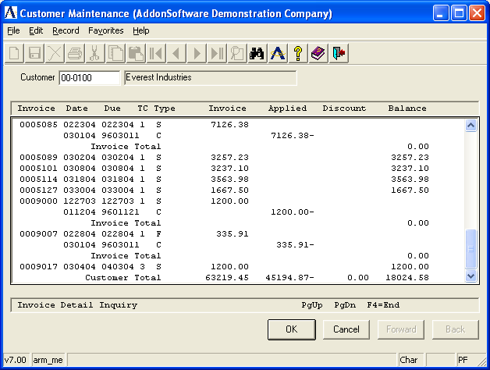

In the Beginning Invoice Number field...
• Enter the number for the first invoice you want to view.
-or-
Press Return to select all invoices.

In the Display Paid, Unpaid Or Both field...
• Enter P to view paid invoices only.
-or-
Enter U to view unpaid invoices only.
-or-
Enter B to view both types of invoices.

All invoices matching your criteria including invoice number, date created, date due, amount owed, etc. are displayed on the screen. Scroll through the invoices, one screen display at a time, by using the PgUp/PgDn keys. When all invoices are displayed press Return or F4 at any time, to return to the Beginning Invoice Number field. Press F4 from this field to return to the Customer Maintenance Options menu.

In the Invoice field...
Display only. Shows the invoice number.

This field may also be used to identify a check number for a payment or a finance charge invoice number.

In the Date field...
Display only. Shows the invoice date. For payment records, this shows the check date.

The slashes between the day, month and year are eliminated to fit the information on one line of the screen.

In the Due field...
Display only. Shows the invoice due date, as determined by the terms code that was associated with the invoice.

The slashes between the month, day, and year are eliminated to fit the information on one line of the screen.

In the TC field...
Display only. Shows the terms code associated with the invoice.

In the Type field...
Display only. Indicates the type of transaction.

S Regular sale
R Return sale (conversion invoices only)
F Finance charge invoice
C Payment (Check)

In the Invoice field...
Display only. Shows the original amount due on the invoice.

In the Applied field...
Display only. Shows the amount of payment (or credit) applied to this invoice.

In the Discount field...
Display only. Shows the amount of discount that is available for this invoice.

In the Balance field...
Display only. Shows the balance due on the invoice.

Ship-To Address Maintenance
The Ship-To Address Maintenance option allows for definition, maintenance and deletion of alternate customer ship-to information. This information is used by the Order/Invoice Processing module to speed the handling of orders for customers with multiple locations. Up to 999,999 different ship-to addresses can be used.

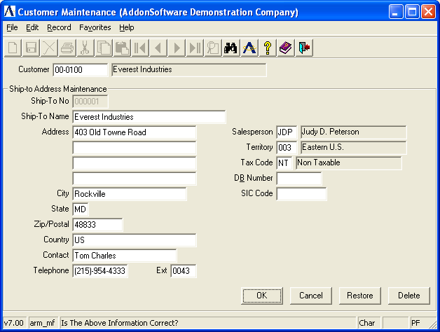

In the Ship-To No field...
• Enter a unique sequence number for the customer’s alternate ship-to address.
-or-
Press F3 to select from a list of all valid numbers.
-or-
Press F4 to return to the Customer Maintenance Options menu.

Note: Avoid using ‘99’ for the ship-to number. The Order/Invoice Processing module uses ‘99’ to identify a custom or manual ship-to address so it will not be accepted here.

When the entry exists, information on the address is displayed. When an entry for the number selected is not found, the following message is issued:

Is This A New Record?

• Enter Y when entering a new record, and proceed to enter the remaining information.
-or-
Enter N if you do not want to establish a new record with this number.

In the Ship-To Name field...
• Enter a name for the business of the Ship-To No.

In the Address field...
• Enter up to five lines to identify the ship-to address.

In the City field...
- Enter up to 22 characters to identify the name of the city associated with the customer.

In the State field...
- Enter 2 characters to identify the name of the state associated with the customer.

In the Zip/Postal field...
• Enter the zip code for the address, with a 4-digit extension if available.

In the Country field...
- Enter up to 22 characters to identify the name of the city associated with the customer.

In the Contact field...
• Enter up to 22 characters for the name of the contact person or department at this location.

In the Telephone field...
• Enter the telephone number, with area code of the ship-to address.

In the Ext field...
• Enter up to four characters for the phone number extension, if applicable.

In the Salesperson field...
• Enter a valid salesperson code.
-or-
Press F3 to select from a list of all valid salesperson codes.

In the Territory field...
• Enter a valid territory code.
-or-
Press F3 to select from a list of all valid territory codes.

In the Tax Code field...
• Enter a valid tax code.
-or-
Press F3 to select from a list of all valid tax codes.

In the D& B Number field…
- Enter the Dunn and Bradstreet number.

In the SIC Code field…
- Enter the Standard Industry Code.

The following prompt is issued:

Is The Above Information Correct?

• Enter Y to accept the information and have it added as an alternate ship-to address with the designated code. The cursor returns to the Ship-To No field.
-or-
Enter N to change any of the information, beginning with the Ship-To Name field.
-or-
Enter a two-digit number to position the cursor at a specific field (i.e. type 10 to go to the tenth field or 5 to move to the fifth).
-or-
Enter Restore to undo any changes you have made since you entered this screen.
-or-
Enter Delete to remove this ship-to file address.

Hard Copy Printing
The Hard Copy Printing task prints a listing of all customer information for the selected customer. All information, including detailed receivable information, is included. This option is helpful during the data conversion process because it allows you to verify the customer information immediately after it is entered. The output is designed to fit on standard 8-1/2 by 11”computer paper. Refer to Appendix A, page 5-24, for a sample copy of the printed report.

Printing
Printing occurs immediately after selecting this option for a customer. After completion, the task returns to the Customer Maintenance Options menu.

Comment Maintenance
Comment Maintenance allows for the creation, modification, deletion, inquiry and listing of customer comment information.

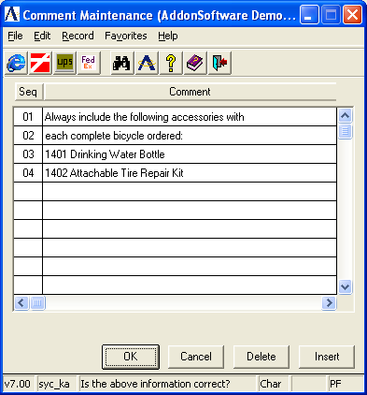

• Use the PgUp/PgDn function keys to view several pages of comments.
-or-
Press F1 to add new comments.
-or-
Press F4 to return to the Customer Maintenance Options menu.
-or-
Select a comment for modification
1. Press Return to access the selected comment.
2. Type over original comment.
-or-
Press F2 to back up and change Seq number.
-or-
Press F4 to access the Line End field where you can enter D to delete.

When you press F1 to add new comments, the system accesses the Comments Maintenance fields beginning with the Seq field.

In the Seq field...
• Enter a two-digit sequence number.
-or-
Press Return to accept the next number in sequential order.

In the Comment field...
• Enter any comment of up to 48 characters in length.

In the Line End field...
• Press Return to accept the comment.
-or-
Enter D to remove the comment.
-or-
Press F2 to return to the Comment field and enter changes.

Open Order Inquiry
When the Order/Invoice Processing module is installed, this option allows inquiry into a customer’s open orders in either a summarized or detailed format. Summarized orders display the order number, type, order date, ship date, PO number, ship-via, salesperson invoice number and the order total. Additionally, the detailed format displays the item description with lot number, warehouse, quantity, price, etc.
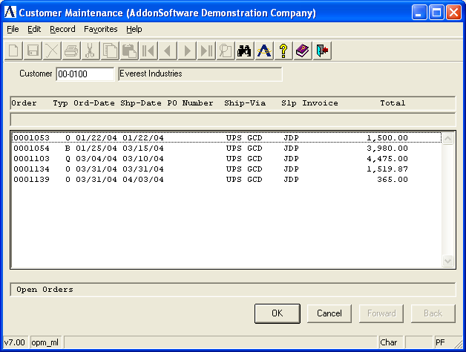

In the Enter Your Option field...
• Enter S to display all of the customer’s open orders in summary format, one line per order.
-or-
Enter D to display the detail line items on a specific order.
-or-
Press F4 to return to the Customer Maintenance Options menu.

In the Beginning Order field...
• Enter a valid order number for this customer.
-or-
Press Return to display all open orders for the customer.

The following prompt is issued:

Enter R To Restart (<Enter>=Continue)

• Press Return to view the next page.
-or-
Enter R to return to the selection screen and start again.
-or-
Press F4 to return to the Customer Maintenance Options menu.

In the Type field…
Display only. Indicates the type of transaction:
O Open order for regular sale
Q Quote
C Order on credit hold
R Order released from credit hold
B Back order

Invoice History Inquiry
When the Order/Invoice Processing module is installed and the Customer Inv Dtl His parameter set to Y, the Invoice History Inquiry option is accessible. This option displays a customer’s historical invoices. Invoice summary or detail information may be viewed if the Retain Invoice Detail History is set to Y in Profile Information.

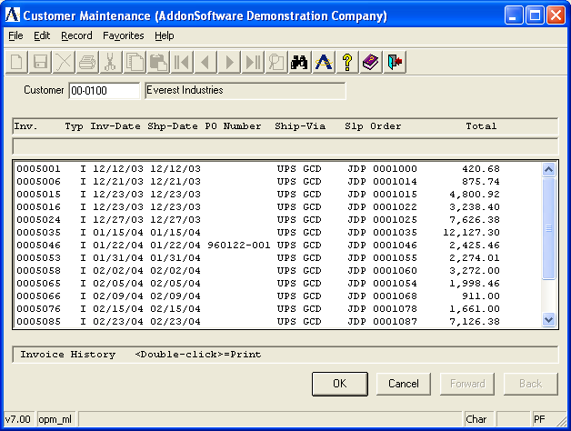

Summarized invoices display the invoice number, type, order date, ship date, PO number, ship-via, salesperson order number and the order total. Additionally, the detailed format displays the item description with lot number, warehouse, quantity, price, etc. A duplicate copy of the invoice can be printed. Refer to Appendix A, page 5-25, for a sample copy of the printed invoice.

In the Enter Your Option field...
• Enter S to display all of the customer’s open orders in summary format, one line per order.
-or-
Enter D to display the detail line items on a specific order.
-or-
Press F4 to return to the Customer Maintenance Options menu.

In the Beginning Invoice Number field...
• Enter a valid invoice number for this customer.
-or-
Press F1 to toggle the field between making a beginning invoice entry or a selected order number entry.
-or-
Press Return to display all historical invoices/orders for the customer.

The following prompt is issued:

Enter R To Restart Or P To Print (<Enter>=Continue)

• Press Return to view the next page.
-or-
Enter R to return to the selection screen.
-or-
Enter P to print a duplicate copy of the invoice/order.
-or-
Press F4 to return to the Customer Maintenance Options menu.

In the Type field…
Display only. Indicates the type of transaction:
I Invoice
V Void

Job Number Maintenance (only exists in character version of AddonSoftware)
Use the Job Number Maintenance option to collect information on jobs for each customer. When a customer’s job number is defined and entered on an invoice, all sales for that job are captured. (see next page)

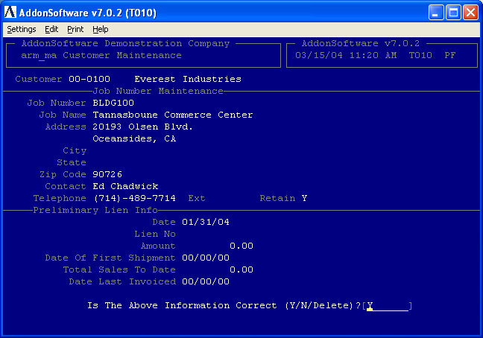

In the Job Number field...
• Enter a number for this job with up to 10 characters.
-or-
Press F4 to return to the Customer Maintenance Options menu.

In the Job Name field...
• Enter a name for this job with up to 30 characters.

In the Address field...
• Enter up to three lines of 24 characters for the address of the job site.

In the Zip Code field...
• Enter the zip code of the job site with the 4-digit extension, if available.

In the Contact field...
• Enter the name of the person of contact.

In the Telephone field...
• Enter the number of the telephone with area code.

In the Ext field...
• Enter the telephone extension, if needed.

In the Retain field...
• Enter Y to retain this information.
-or-
Enter N to purge this information.

An entry in the Order Processing Parameter Maintenance determines the number of months job information is retained.

Preliminary Lien Info
In the Date field...
• Enter the date of the lien.

In the Lien No field...
• Enter the number assigned to the lien.

In the Amount field...
• Enter the amount of the lien.

In the Date Of First Shipment field...
Display only. Shows the date you first made delivery on this job.

In the Total Sales To Date field...
Display only. Shows the amount of total sales for this customer against this job.

In the Date Last Invoiced field...
Display only. Shows the date of your last invoice to this customer for this job.

The following prompt is issued:

Is The Above Information Correct?

• Enter Y when the above information is correct.
-or-
Enter N when the information is incorrect. You will return to the Job Name field.
-or-
Enter Delete to remove this information from the system.

Customer Type Maintenance
The Customer Type Maintenance task allows for the creation, modification, deletion, inquiry, and listing of customer type codes used by the Order/Invoice Processing and Sales Analysis modules.

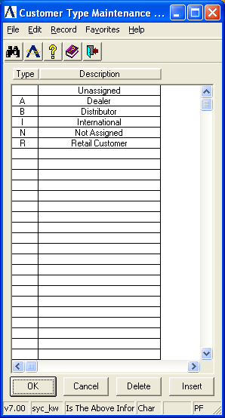

Each customer is assigned a customer type that is entered in Customer Maintenance. Customer types are used by the Sales Analysis module to record sales history by customer type and product code. Refer to Appendix A, page 5-26, for a sample copy of the printed records.

- Select the customer type by highlighting the appropriate description and press Enter.
-or-
Press F4 to return to the main menu/or to print a list of customer types.

To add/change/delete customer types, follow these steps:

In the Customer Type field...
• Enter a customer type code of up to three characters in length.
-or-
Press Return to display the next customer type in the file.
-or-
Press F3 to select from a list of all valid customer codes.
-or-
Press F4 to return to the menu.

When the customer type code is created, the corresponding information is displayed. For a customer type code that does not exist, the system will issue the following prompt:

Is This A New Record?

• Enter Y to establish a new record with the entered code.
-or-
Enter N if you do not want to set up a customer type with this code.

In the Description field...
• Enter up to 20 characters to describe the customer type.

When you have finished making entries to the fields, the following prompt is issued:

Is The Above Information Correct?

• Enter Y when the above information is correct and return to the Customer Type field.
-or-
Enter N to make a change.
-or-
Enter Delete to remove the record from the file.

When you press F4 to leave this option, the following prompt is issued:

Print A List Of All Records?

• Enter Y to print the list.
-or-
Enter N to return directly to the menu.

Salesperson Maintenance
The Salesperson Maintenance task allows for the creation, modification, deletion, inquiry and listing of salesperson codes used by the Order/Invoice Processing and Sales Analysis modules. Refer to Appendix A, page 5-27, for a sample copy of the printed records.

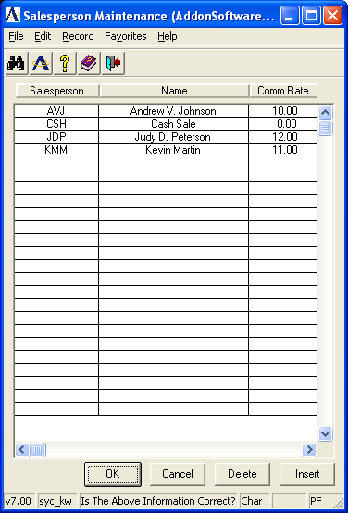

- Select the salesperson by highlighting the appropriate name and press Enter.
-or-
Press F4 to return to main menu/or print a list of names.

To add/change/delete customer types, take the following steps:

In the Salesperson field...
• Enter a 3-character salesperson code.
-or-
Press Return to display the next sequential code on file.
-or-
Press F3 to select from a list of all valid salesperson codes.
-or-
Press F4 to return to the menu.

When the salesperson code is set up, its information is displayed. When the code does not exist, the following prompt is issued:

Is This A New Record?

- Enter Y to establish a new record with the entered code.
-or-
Enter N if you do not want to make a new entry and return to the Salesperson field.

In the Name field...
• Enter up to 20 characters for the name of this salesperson.

In the Comm Rate field...
• Enter a number that represents the commission rate for this salesperson.

Example
Enter 5.5 to represent a commission of 5.5% (.055).

When you finish with the entries to the fields, the following prompt is issued:

Is The Above Information Correct?

• Enter Y when the above information is correct and return to the Salesperson field.
-or-
Enter N to make a change. You are returned to the Name field.
-or-
Enter Delete to remove the record from the file.

When you press F4 to leave this option, the following prompt is issued:

Print A List Of All Records?

• Enter Y to print the list.
-or-
Enter N to return directly to the menu.

Terms Code Maintenance
The Terms Code Maintenance task allows for the creation, modification, deletion, inquiry and listing of terms codes used in Order/Invoice Processing, Conversion Invoice Entry, Simple Invoice Entry and Cash Receipts.

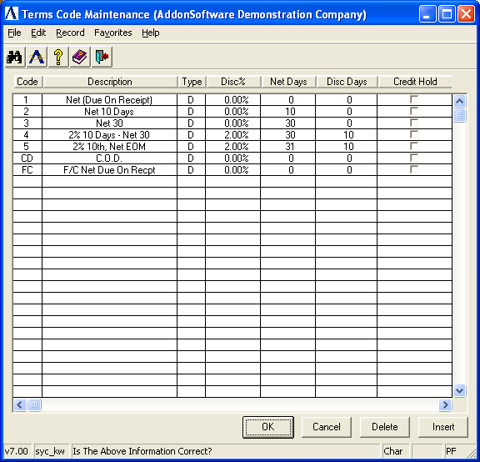

Once established, terms codes are associated with each customer record. When a terms code is used, its definition will automatically determine an invoice due date and discount due date, if applicable. Refer to Appendix A, page 5-28, for a sample copy of the printed records.
When the terms code is set up, it will be automatically displayed.

- Select a terms code by highlighting the appropriate description using up/down arrows and press Enter.
-or-
Press F4 to return to main menu/or print a list of codes.

To add/change/delete terms codes, take the following steps:

In the Terms Code field...
• Enter a terms code of up to 2-characters.
-or-
Press Return to display the next sequential code along with its information.
-or-
Press F3 to select from a list of all valid terms code.
-or-
Press F4 to return to the menu.

In the Description field...
• Enter up to 20 characters to describe the terms.

In the Type field...
• Enter D for terms based on a specific number of days from the invoice date.
-or-
Enter P for prox terms based on a specific day in the next month.

In the Discount % field...
• Enter a number that represents the discount rate available for these terms.

If no discount is offered, enter 0.

Example
Enter 2.5 to represent a prompt payment discount of 2.5% (.025).

In the Net Day(s) field...
• Enter the number of days past the invoice date when the total amount of the invoice is due after you select D in the Type field.
-or-
Enter the invoice due date of the next month (1 through 31) by selecting P in the Type field. For prox terms, enter 31 to represent the last day of the following month.

In the Discount Days field...
• Enter the number of days past the invoice date when a prompt payment discount may be taken by selecting D in the Type field.
-or-
Enter the day of the month to take a prompt payment discount when P is selected in the Type field. For prox terms, the discount date is always the day of the following month.

In the Credit Hold field...
• Enter Y when you want a credit hold for all customers with these terms.
-or-
Enter N if you do not want a credit hold.

The following prompt is issued:

Is The Above Information Correct?

• Enter Y when the above information is correct and return to the Terms Code field.
-or-
Enter N to make a change.
-or-
Enter Delete to remove the record from the file.

When you press F4 to leave this option, the following prompt is issued:

Print A List Of All Records?

• Enter Y to print the list.
-or-
Enter N to return directly to the menu.

Terms Codes Examples

Example 1: Example 2:
Invoice is due when it is Invoice is due 30 days
created - no discount is from invoice date - no
offered. discount is offered.

Code: 00 Code: 30
Description: Due on Receipt Description: Net 30 Days
Type: D Type: D
Discount: 0.0% Discount: 0.0%
Net Day(s): 00 Net Day(s): 30
Discount Days: 0 Discount Days: 0
Credit Hold: N Credit Hold: N

Example 3: Example 4:
Invoice is due 30 days after Invoice is due at the
created - a 2% early payment may end of the month after discount taken if the payment is was created.
received within 10 days.

Code: 10 Code: 31
Description: 2% 10 Net 30 Description: Net EOM
Type: D Type: P
Discount: 2.0% Discount: 0.0%
Net Day(s): 30 Net Day(s): 31
Discount Days: 10 Discount Days: 0
Credit Hold: N Credit Hold: N

Example 5: Example 6:
Invoice is due at the end of Cash on delivery - as
the month after it is created. may apply to a will call
A 2% discount may be taken sale or C.O.D. delivery.
if payment is received by the
10th of the following month.

Code: 11 Code: CD
Description: 2% 10th Net EOM Description: C.O.D.
Type: P Type: D
Discount: 2.0% Discount: 0.0%
Net Days(s): 31 Net Day(s): 0
Discount Days: 10 Discount Days: 0
Credit Hold: N Credit Hold: N

Territory Code Maintenance
The Territory Code Maintenance task allows for the creation, modification, deletion, inquiry and listing of territory codes used in the Order/Invoice Processing and Sales Analysis modules. Territory codes can also be used for setting a range for printing customer statements.

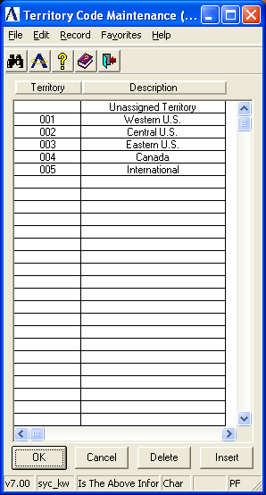

Once established, territory codes are associated with each customer record and become part of the order/invoice heading information. If your business does not have distinct sales territories, you must set up at least one territory code that is used by all customers. Refer to Appendix A, page 5-29, for a sample copy of the printed records.

In the Territory Code field...
• Enter a 3-character territory code.
-or-
Press Return to display the next sequential code.
-or-
Press F3 to select from a list of all valid territory codes.
-or-
Press F4 to return to the menu.

When the territory code is set up, the territory code information is displayed. When the territory code does not exist the following prompt is issued:

Is This A New Record?

• Enter Y to establish a new record with the entered code.
-or-
Enter N when you do not want to establish a new record with this code. You are returned to the Territory Code field.

In the Description field...
• Enter up to 20 characters to describe the territory.

The following prompt is issued:

Is The Above Information Correct?

• Enter Y when the above information is correct and return to the Territory Code field.
-or-
Enter N to make a change.
-or-
Enter Delete to remove the record from the file.

When you press F4 to leave this option, the following prompt is issued:

Print A List Of All Records?

• Enter Y to print the list.
-or-
Enter N to return directly to the menu.

Cash Receipts Code Maintenance
The Cash Receipts Code Maintenance task allows for the creation, modification, deletion, inquiry and listing of cash receipts codes used in Cash Receipts Entry. Cash Receipt Codes are used to identify bank accounts, type of payment and the source of payment or adjustment entries. Refer to Appendix A, page 5-31, for a sample copy of the printed records.

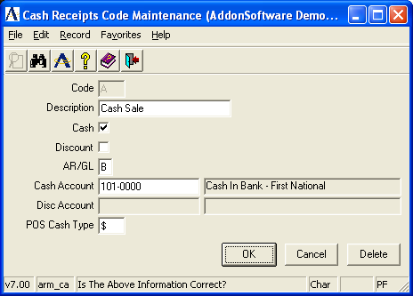

In the Code field...
• Enter a cash receipts code of up to 3 characters in length.
-or-
Press Return to display the next sequential code.
-or-
Press F3 to select from a list of all cash receipt codes.
-or-
Press F4 to return to the menu.

When the cash receipts code is set up, its information is displayed. When the cash receipts code does not exist the following prompt is issued:

Is This A New Record?

• Enter Y to establish a new record with the entered code.
-or-
Enter N if you do not want to set up a new record with this code.

In the Description field...
• Enter up to 20 characters to describe this cash receipts code.

In the Cash field...
• Enter Y to enter adjustments and deposit amount (cash or check) with this code during the cash receipts data entry.
-or-
Enter N if adjustments only can be made.

An entry of N will not allow a cash amount and is useful to control adjusting type transactions.

Using the Graphical Interface:
- Click on the check box to indicate Yes, include adjustments and deposit amounts during the cash receipts data entry.
-or-
Press Enter to leave blank and proceed to the next field.

In the Discount field...
• Enter Y to allow discounts to be taken with this code during Cash Receipts Entry.
-or-
Enter N if discounts are not permitted with this code.

Using the Graphical Interface:
- Click on the check box to indicate Yes, allow discounts to be taken with this code during Cash Receipts Entry.
-or-
Press Enter to leave blank and proceed to the next field.

In the AR/GL field...
• Enter A to post these receipts to accounts receivable invoices.
-or-
Enter G to post these receipts to general ledger accounts.
-or-
Enter B to allow both.

In the Cash Account field with GL installed...
• Enter a valid general ledger cash account.
-or-
Press F3 to select from a list of all valid accounts.

Post the cash amount to this account during the Cash Receipts Update. When depositing into several accounts, create a cash receipt code for each account.

In the Disc Account field with GL installed...
You must answer Y in the Discount field in order for this field to be activated.
• Enter a valid general ledger account to post allowed discounts.
-or-
Press F3 to select from a list of all valid accounts.

Post terms discount amounts to this account when they are taken by a customer. This account is normally a contra-revenue account posted as a debit amount as part of the Cash Receipts Update process.

In the POS Cash Type field with OP installed...
• Enter $ for cash point-of-sale transactions.
-or-
Enter C for check point-of-sale transactions.
-or-
Enter P for credit card point-of-sale transactions.

This field is not used by the cash receipts processing in the Accounts Receivable module, though a value must still be entered. The POS Cash Type is used by the Order/Invoice Processing to process point-of-sale invoices. The value entered causes a related set of questions to be asked on the total screen of the Simple Invoice Entry task.

The following prompt is issued:

Is The Above Information Correct?

• Enter Y when the above information is correct and return to the Code field.
-or-
Enter N to make a change.
-or-
Enter Delete to remove the record from the file.

When you press F4 to leave this option, the following prompt is issued:

Print A List Of All Records?

• Enter Y to print the list.
-or-
Enter N to return directly to the menu.

Distribution Code Maintenance
The Distribution Code Maintenance allows for the creation, modification, deletion, inquiry and listing of distribution codes used to determine general ledger postings during the Accounts Receivable billing and Order/Invoice entry functions. Refer to “How Distribution Codes Work” in Appendix B.

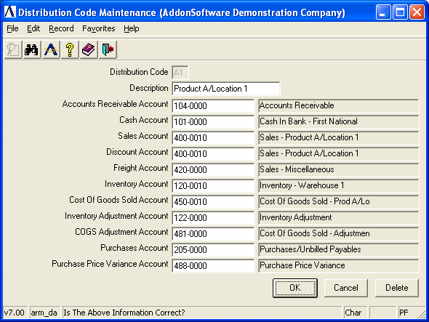

Distribution codes are assigned directly to customers in the Customer Masterfile and optionally, in the Inventory Item Masterfile. This allows you to associate multiple receivable accounts with the customer base, if desired. Refer to Appendix A, page 5-32, for a sample copy of the printed records.

In the Distribution field...
• Enter a 2-character alphanumeric distribution code.
-or-
Press Return to display the next sequential code along with its information.
-or-
Press F3 to view a list of valid distribution codes.
-or-
Press F4 to return to the menu.

When the distribution code is set up, the distribution code information is displayed. If the distribution code does not exist, the following prompt is issued:

Is This A New Record?

• Enter Y if you want to establish a new record with the entered code.
-or-
Enter N if you do not want to set up a new record with this code.

In the Description field...
• Enter up to 20 characters to describe this cash receipts code.

In the AR Acct field...
• Enter a valid general ledger account number.
-or-
Press F3 to select from a list of all valid account numbers.

This account will normally be the simple invoices and invoices generated by the Order/Invoice Processing module. Also, remember that the General Ledger module must be installed to access the GL account fields.

In the Cash Acct field... accounts receivable control account that is debited during the update process for conversion invoices…
• Enter a valid general ledger account.
-or-
Press F3 to select from a list of all valid account numbers.

This account is used in posting cash sales transactions generated by the Order/Invoice Processing module.

In the Sales Acct field...
• Enter a valid general ledger account number.
-or-
Press F3 to select from a list of all valid account numbers.

This account is used in posting revenue to the general ledger.

NOTE: When the Order/Invoice Processing and Inventory Control modules are installed, the selection of a distribution code for revenue posting is dependent on the Distribute Sales By Item parameter in the Accounts Receivable Parameter Maintenance task. If this parameter is set to Y, the revenue accounts are determined by the distribution code associated with each inventory item. If the parameter is set to N, these accounts are taken from the distribution code that is associated with the customer, which becomes the default value for the Order/Invoice header.

In the Discount field...
• Enter a valid general ledger account number to post allowed discounts.
-or-
Press F3 to select from a list of all valid account numbers.

NOTE: This account is used for sales discounts; it is not used for terms discounts. It will also post transactions to the discounts allowed, where the posting amount is taken from the overall invoice discount that is available in the Order/Invoice Processing module.

In the Freight Acct field...
• Enter a valid general ledger account number.
-or-
Press F3 to select from a list of all valid account numbers.

This account is used in posting freight revenue that is entered on invoices generated by the Order/Invoice Processing module.

In the Inv Acct field...
• Enter a valid general ledger account number.
-or-
Press F3 to select from a list of all valid account numbers.

This account is used in posting transactions to an inventory asset account. This is applicable only to invoices generated by the Order/Invoice Processing module.

In the COGS Acct field...
• Enter a valid general ledger account number.
-or-
Press F3 to select from a list of all valid account numbers.

This is applicable only to invoices generated by the Order/Invoice Processing module.

The following prompt is issued:

Is The Above Information Correct?

• Enter Y if the above information is correct and return to the Code field.
-or-
Enter N if you want to make a change.
-or-
Enter Delete if you want to remove the record from the file.

In the Inventory Adjustment Acct field…
- Enter a valid general ledger account number.
-or-
Press F3 to select from a list of all valid account numbers

This account is used to record adjusting transactions rather than posting them directly to an inventory account. The Inventory Adjustment Transaction is an example of its use. This is a contra asset account.

In the COGS Adjustment Acct field…
- Enter a valid general ledger account number.
-or-
Press F3 to select from a list of all valid account numbers.

This account is used to record adjusting transactions rather than posting them directly to a cost of goods sold account. This is an expense account.

In the Purchases Acct field…
- Enter a valid general ledger account number.
-or-
Press F3 to select from a list of all valid account numbers.

This account is used to record the value of incoming Purchase Orders that were received and no vendor invoice was issued. This is an asset account.

In the Purchase Price Variance Account field…
- Enter a valid general ledger account number.
-or-
Press F3 to select from a list of all valid account numbers.

This account is used to accumulate the differences in the cost of items from vendors. This is an expense account.

When you press F4 to leave this option, the following prompt is issued:

Print A List Of All Records?

• Enter Y to print the list.
-or-
Enter N to return directly to the menu.

Cycle Code Maintenance
The Cycle Code feature enables your customer base to be divided into separate groups. This allows statements to be sent out over the course of the month in a staggered manner, rather than mailing all customer statements at the same time which can be problematic depending on the size of your customer base.

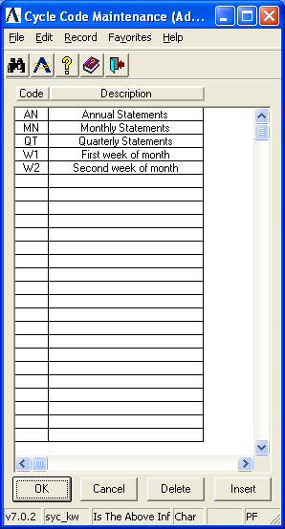

In the Cycle Code field...
• Enter a 2-character cycle code.

In the Description field...
• Enter up to 20 characters to describe the code. Then press Enter.

The following prompt is issued:

Is The Above Information Correct?

• Enter Y when the above information is correct and return to the Cycle Code field.
-or-
Enter N to make a change.
-or-
Enter Delete to remove the record from the file.

When you press F4 to leave this option, the following prompt is issued:

Print A List Of All Records?

• Enter Y to print the list.
-or-
Enter N to return directly to the menu.

Accounts Receivable Parameter Maintenance
The Accounts Receivable Parameter Maintenance task allows for the creation, modification, deletion and inquiry of the Accounts Receivable module parameters. In this task, you can tailor the Accounts Receivable module to the way you do business. The options presented here may be changed at a later date. Consult with your AddonSoftware Dealer before making any changes after your module is in operation.

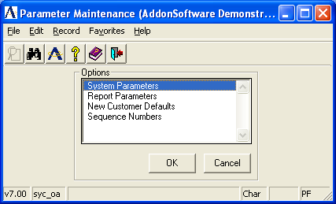

About the AR Parameter Maintenance Menu Options
The Accounts Receivable Parameter Maintenance Option Menu allows you to work on one parameter after another without ever leaving the Accounts Receivable Parameter Maintenance task. Once a parameter option is chosen, you can make adjustments to the settings. When you select an option from the menu, the list of options disappears from the screen and the parameter fields of the option you selected are displayed on the screen.

System Parameters
Use this option to set the parameters system wide for the selected company.

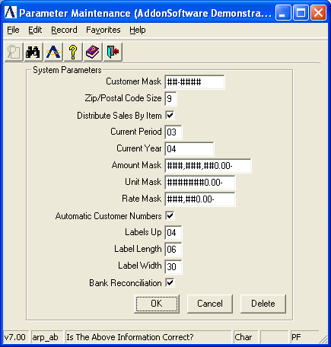

When you select this option, all existing parameters are displayed and the following prompt is issued:

Is The Above Information Correct?

- Enter Y if the above information is correct and return to the AR Parameter Maintenance Menu.
-or-
Enter N to make a change.
-or-
Enter Delete to remove the parameters from the file.

In the Customer Mask field...
• Enter a mask of up to 6 characters.

The customer number structure that is referenced throughout the entire module is defined by a “mask.” Determine the mask for your customer number and enter it here.

The mask is made up of the characters `#’ and `-’. For example, the mask #-##### may represent a one digit customer type and a five-digit customer number. The customer mask may not have more than six `#’ characters. (Dashes in the mask do not count as one of the six characters.)

In the Zip/Postal Code Size field...
• Enter 5 to set a zip/postal code parameter without the four-digit extension.
-or-
Enter 9 to set a zip/postal code parameter with an extension.

The parameter may be changed from 5 to 9 at a later time; however, you should not change from 9 to 5.

In the Distribute Sales By Item field...
• Enter Y for general ledger distribution by inventory items.
-or-
Enter N for general ledger distribution by customer.

This parameter allows you to control the method by which general ledger revenue accounts are posted during the invoice update process in the Order/Invoice Processing module. With inventory items (Y option), the revenue account is taken directly from a distribution code associated with each inventory item on the invoice. The distribution code contains all of the necessary inventory detail information. However, when selecting the N option, the revenue account is taken from the distribution code associated with a customer (which may be overridden at Order/Invoice Entry time). Because the customer distribution code does not contain the necessary inventory detail information, you must also enter general ledger accounts in Item Maintenance. This parameter has no effect on the general ledger postings made during Conversion Invoice processing or Simple Invoice processing.

Using the Graphical Interface:
Click on the check box to indicate Yes, to distribute sales by inventory item.
-or-
Press Enter to leave blank and proceed to the next field.

In the Current Period field...
• Enter the current Accounts Receivable period.

Enter a number between 1 and 13, which represents the current period of operation. The period indicator is automatically incremented as part of the Accounts Receivable Period-End process. The current period indicator is independent of the current period indicator in the General Ledger module.

Once a system is operational, you should consult your dealer and discuss the ramifications before making any changes to this field.

In the Current Year field...
• Enter the current fiscal year.

Use the calendar year in which the first fiscal period ends. It is incremented automatically when the period-end update is run for the last period of the fiscal year.

In the Amount Mask field...
• Enter the mask to be used for extended amounts.

The amount mask defines the largest dollar amount (including totals) found in the Accounts Receivable module. Refer to Guidelines for Defining Numeric Masks as explained in the Installation section. Any of the following characters can be utilized: #$0()*-,.CRDB. Be sure to allow for negative amounts.

Example
A mask of ###,###.00CR will accommodate an amount of 999,999.00. Negative amounts will appear with a CR (credit) to the right of the amount such as 500.00CR.

In the Unit Mask field...
• Enter the mask to be used for units.

The unit mask defines the format of the amount field in Simple Invoice processing. Refer to Guidelines for Defining Numeric Masks as explained in the Installation section. Any of the following characters can be utilized: #$0()*-,.CRDB. Be sure to allow for negative amounts.

In the Rate Mask field...
• Enter the mask to be used for rates.

The rate mask defines the format of the Price field in Simple Invoice processing. Any of the following characters can be used: #$0()*-,.CRDB.

NOTE: If you a zero value to print as “blank” on the Simple Invoices, set up the masks using the “#” character exclusively, not “0” (i.e. #,###.##-).

In the Automatic Customer Number field...
• Enter Y to have the module assign new customer numbers automatically in Customer Maintenance. If you select this option, new customer numbers may still be assigned manually. This automatic option will not apply to alpha-numeric combinations.
-or-
Enter N to assign all customer numbers.

Using the Graphical Interface:
- Click on the check box to indicate Yes, use automatic customer numbers.
-or-
Press Enter to leave blank and proceed to the next field.

In the Labels Up field...
• Enter a number from 1-4 that determines how many mailing labels are printed across the page.

In the Label Length field...
• Enter the number of print lines between the top of the first label and the top of the next label down. Six (6) lines are standard.

In the Label Width field...
• Enter the width of the label.

This is the number of characters between the start of the first label across and the start of the second label across. Thirty-six (36) characters is standard for 1, 2, and 3 labels up. Thirty (30) characters are standard for 4 labels up.

In the Bank Reconciliation field...
• Enter Y when the Bank Reconciliation system is installed and you want to update deposits.
-or-
Enter N for no bank reconciliation of deposits.

Using the Graphical Interface:
- Click on the check box to indicate Yes, use bank reconciliation to update deposits.
-or-
Press Enter to leave blank and proceed to the next field.

Report Parameters
Report Parameters are used to define the company name and address for printing on the Simple Invoice forms.

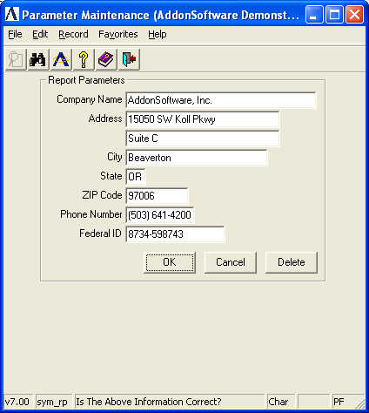

When you select this option, all existing parameters are displayed and the following prompt is issued:

Is The Above Information Correct?

• Enter Y when the above information is correct and you want to return to the Parameter Maintenance Option Menu.
-or-
Enter N to make a change.
-or-
Enter Delete to remove the parameters from the file.

In the Company Name field...
• Enter the company name using up to 30 characters.

This is the name of your company used for tax reporting purposes.

In the Address field...
• Enter an address of up to 3 lines and 24 characters per line.

This is the address of your company, as you would like it to appear on the simple invoices.

In the City field...
- Enter the name of the city using up to 22 characters.

In the State field...
- Enter the name of the state using 2 characters.

In the Telephone Number field…
- Enter the customer’s telephone number. This telephone number will not print on the invoice.

In the Federal ID field...
• Enter the company’s federal ID with up to 15 characters.

This is the employer identification number used for tax reporting purposes. This information does not print on the invoice.

New Customer Defaults
When a new customer is entered in the Accounts Receivable Customer Maintenance task, new customer default information is displayed. This standard sales information, common to the majority of your sales orders and invoices, can be overridden as desired.

NOTE: New Customer Defaults in the AR module is for permanent customers, while the New Customer Defaults task in Order/Invoice Processing is designed for temporary customers.

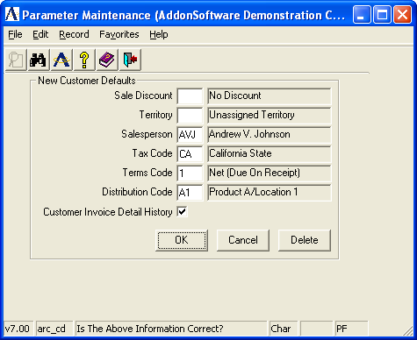

In the Sale Discount field...
• Enter a valid sale discount code.
-or-
Press Return to accept the default.
-or-
Press F3 to select from a list of valid codes.

In the Territory field...
• Enter a valid territory code.
-or-
Press Return to accept the default.
-or-
Press F3 to select from a list of valid codes.

In the Salesperson field...
• Enter a valid salesperson code.
-or-
Press Return to accept the default.
-or-
Press F3 to select from a list of valid codes.

In the Tax Code field...
• Enter a valid tax code.
-or-
Press Return to accept the default.
-or-
Press F3 to select from a list of valid codes.

In the Terms Code field...
• Enter a valid terms code.
-or-
Press Return to accept the default.
-or-
Press F3 to select from a list of valid codes.

In the Distribution Code field...
• Enter a valid distribution code.
-or-
Press Return to accept the default.
-or-
Press F3 to select from a list of valid codes.

In the Customer Inv Dtl His field...
• Enter Y to retain full invoice detail history.
-or-
Enter N to ignore invoice history.
-or-
Press F3 to select from a list of valid codes.

When you finish making entries to the fields, the system issues the Is The Above Information Correct? prompt again.

Sequence Numbers
This option sets the first, or next, number for the automatic sequencing features of the Accounts Receivable and Order Processing modules. These numbers are automatically incremented when used by the system.

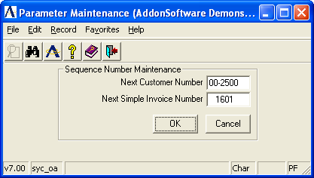

When you select this option, all existing sequence numbers are displayed and the following prompt is displayed:

Is The Above Information Correct?

- Enter Y when the above information is correct and you want to return to the Parameter Maintenance Option menu.
-or-
Enter N to make a change.

In the Next Customer Number field…
- Enter 6 digits for the next customer number generated when adding a customer in Customer Maintenance.

NOTE: This field is used only when the Automatic Customer Number parameter is set to ‘Y’ in AR System Parameter Maintenance.

In the Next Simple Invoice Number field…
- Enter the next 7-digit invoice number used in Simple Invoicing.

Accounts Receivable Utilities
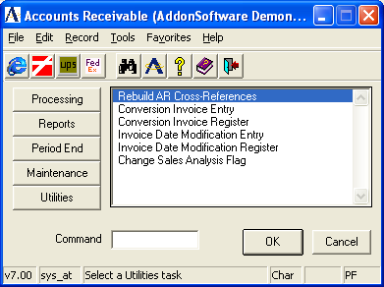
Accounts Receivable Utilities Menu

Function
The Accounts Receivable Utilities menu provides access to tasks used for special functions. The items on this menu should only be used after consultation with your dealer and accounting professional. Only operators with special permission (refer to User Maintenance) may access this menu.

n To access the Accounts Receivable Utilities menu...

Press the Utilities button after accessing Accounts Receivable, or enter ARX at any menu prompt.

About the AR Utilities Tasks
To access any task on this menu, enter the number assigned to the task in the Enter An Option field.

Rebuild AR Cross-Reference File
This task rebuilds cross-reference records for customers, including alternate sequence, zip code, contact, salesperson, phone number, territory, etc. This task should be used to correct any inconsistencies in these sorts. To check the integrity of the file, run a Customer Cross/Reference Report and check that the alphabetic and numeric columns have the same number of entries.

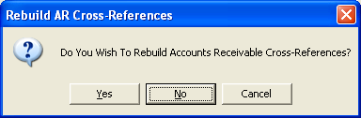

The following prompt is issued:

Do You Want To Rebuild Accounts Receivable Cross-References?

• Enter Yes to rebuild the cross-reference file.
-or-
Enter No to return to the menu.

NOTE: This task rebuilds cross-references for all companies at the same time. All accounts receivable activity must cease while this task is run. If the task is interrupted, it must be started from the beginning and allowed to run to completion.

Conversion Invoice Entry
The Conversion Invoice Entry task creates summary invoice records that are posted to the customer’s account and, optionally, to the general ledger. These records represent open accounts receivable invoices.

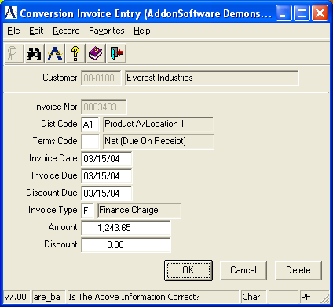

This task is used to enter invoices that existed prior to the installation of the Accounts Receivable module (Conversion Invoices). It may also be used to post after-the-fact invoices in systems where there is no Order/Invoice processing module installed.

NOTE: This task may also be used to modify, add, or delete finance charge records to the Finance Charge Register. It is recommended that regular conversion invoices and finance charges be entered in two separate batches to avoid confusion between the two processes.

In the Customer Number field...
• Enter a valid customer number.
-or-
Press F3 to select from a list of all valid customer numbers.
-or-
Press F4 to return to the menu.

When the customer number already exists, the customer name is displayed. Otherwise you are prompted to enter another number.

In the Name field...
Display only. Shows the name associated with the customer number.

In the Invoice Nbr field...
• Enter a seven-digit invoice number.

NOTE: If the invoice is already in the module, you will not be able to enter the transaction. To adjust invoices, refer to Cash Receipts Entry or Simple Invoice Entry.

In the Dist Code field...
• Enter a valid distribution code.
-or-
Press F3 to select from a list of all valid codes.
-or-
Press Return to accept the default code associated with the customer.

The description of the code is displayed. The distribution code determines the general ledger account numbers for sales, accounts receivable and discounts when the invoice is updated and the update option is selected.

In the Terms Code field...
• Enter a valid terms code.
-or-
Press F3 to select from a list of all valid terms codes.
-or-
Press Return to accept the terms code associated with the invoice.

The description of the code is displayed. The terms code will determine the invoice due date and discount due date using the invoice date as a basis for calculation.

In the Invoice Date field...
• Enter the date that the invoice is to be posted to general ledger.
-or-
Press Return to accept the terminal date.

This date is used as the reference point by the terms code to determine the due date and discount due date of the invoice. These dates are displayed and may be overridden as needed.

Example
When the invoice date is 10/10/04 and the terms code is 2% 10 NET 30, then the discount is due 10/20/04 and the invoice is due 11/09/04.

In the Invoice Due field...
• Enter the due date of the net invoice.
-or-
Press Return to accept the terminal date.

In the Discount Due field...
• Enter the due date of the net invoice.
-or-
Press Return to accept the terminal date.

Example
When the discount due date is 10/20/04, the customer may receive a discount (if applicable) by paying on or before this date.

In the Invoice Type field...
• Enter S for a sale transaction.
-or-
Enter R for a return of merchandise transaction or service or a credit memo.
-or-
Enter F for a finance charge transaction.

In the Amount field...
• Enter the total amount of the invoice.

In the Discount field...
• Enter the amount of discount available on this invoice.

NOTE: Discounts are recorded as memo amounts only at this point. They are not posted to the general ledger until after they are actually taken. This is determined during cash receipts processing.

The following prompt is issued:

Is The Above Information Correct?

• Enter Y when the fields are correct.
-or-
Enter N to change any field.
-or-
Enter Delete to remove the settings.

Conversion Invoice Register
The Conversion Invoice Register task prints a report of all conversion invoices prior to making postings to the customers’ accounts. Conversion invoices may be optionally posted to the general ledger. Refer to Appendix A, page 5-12, for a sample copy of the report.

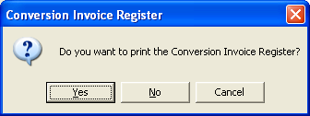

The following prompt is issued:

Are You Ready To Update The Register?

• Enter Yes when the information on the register is correct.
-or-
Enter No if the information is not correct or you want to return to the menu. You may then re-enter the Conversion Invoice Entry task to make any changes required and print the register later.

The following prompt is issued when you answer Yes to the Update Register prompt:

Do You Want To Update General Ledger From This Register?

• Enter Yes to post the conversion invoices to the general ledger using the distribution codes associated with each invoice.
-or-
Enter No if you do not want to post transactions to the general ledger, but still have them added to the accounts receivable open item file.
-or
Press F4 to return to the menu without updating anything.

NOTE: The primary purpose of not updating to general ledger is for conversion purposes when you are entering invoices into the open invoice file and these invoices have already been recorded in the general ledger. However for daily processing, if you have a live general ledger system, you should always answer Yes to avoid having your accounts receivable general ledger control account(s) out of balance with the accounts receivable subsidiary ledger.

Updating
The conversion invoices are posted to the customer accounts. When you selected to post to general ledger, the amount of the invoice is debited to the accounts receivable account and credited to the revenue account associated with the invoice distribution code.

Invoice Date Modification Entry
The Invoice Date Modification Entry task allows modification of terms code, invoice date, due date and discount date for customer open invoices.

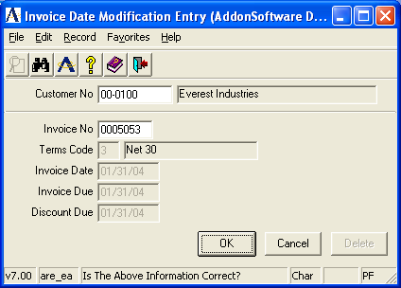

NOTE: This task will modify the invoice date, due date, and discount due, or any combination of the three. It does not, however, modify dates in Invoice History Inquiries. Care should be taken when using this task that associated general ledger transactions be adjusted as well.

In the Customer Number field...
• Enter a valid customer number.
-or-
Press F3 to select from a list of all valid customer numbers.
-or-
Press F4 to return to the menu.

When the customer number already exists, the customer name is displayed. Otherwise, you are prompted to enter another number.

In the Name field...
Display only. Shows the name associated with the customer number.

In the Invoice Nbr field...
• Enter a seven-digit invoice number.

NOTE: If the invoice is already in the module, you will not be able to enter the transaction. To adjust invoices, refer to Cash Receipts Entry or Simple Invoice Entry.

In the Terms Code field...
• Enter a valid terms code.
-or-
Press F3 to select from a list of all valid codes.
-or-
Press Return to accept the terms code associated with the invoice.

The description of the code is displayed. The terms code will determine the invoice due date and discount due date using the invoice date as a basis for calculation.

In the Invoice Date field...
• Enter the date that the invoice is to be posted to general ledger.
-or-
Press Return to accept the terminal date.

This date is used as the reference point by the terms code to determine the due date and discount due date of the invoice. These dates are displayed and may be overridden if desired.

Example
When the invoice date is 10/10/04 and the terms code is 2% 10 NET 30, the discount is due 10/20/04 and the invoice is due 11/09/04.

In the Invoice Due field...
• Enter the date that the net invoice is due.
-or-
Press Return to accept the terminal date.

In the Discount Due field...
• Enter the date that a discount is given if payment is received.
-or-
Press Return to accept the terminal date.

Example
When the discount due date is 10/20/04, the customer may receive a discount (if applicable) by paying on or before this date.

The following prompt is issued:

Is The Above Information Correct?

• Enter Y when the fields are correct.
-or-
Enter N to change any field.
-or-
Enter Delete to remove the invoice.

NOTE: Typing Delete does not remove the invoice from the accounts receivable open invoice file, only from the Data Entry file.

Invoice Date Modification Register
The Invoice Date Modification Register task prints a report of all modified invoices prior to making the adjustments to the accounts receivable open invoice file.

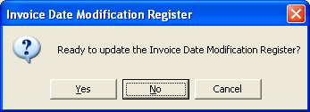

Printing begins immediately upon accessing the task. Press F4 to interrupt the printing process. Refer to Appendix A, page 5-30, for a sample copy of the register.

The following prompt is issued:

Are You Ready To Update The Invoice Date Modification Register?

• Enter Yes when the information on the register is correct.
-or-
Enter No if it is not correct or you want to return to the menu.

Updating
The modifications are made to the open invoices as the invoice number is displayed on the screen. General Ledger postings are not made as part of the update.

Change Sales Analysis Flag
This task allows for the Sales Analysis flag to be changed in bulk for a singe customer, or for a range of customer numbers.

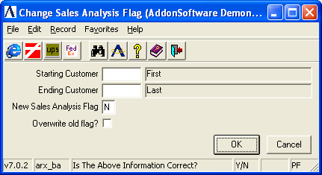

In the Starting Customer field...
• Enter a valid beginning customer number.
-or-
Press F1 to select the first valid customer number.
-or-
Press F3 to select from a list of all valid customer numbers.
-or-
Press F4 to return to the menu.

When the customer number already exists, the customer name is displayed. Otherwise, you are prompted to enter another number.

In the Ending Customer field...
• Enter a valid ending customer number.
-or-
Press F1 to select the last valid customer number.
-or-
Press F3 to select from a list of all valid customer numbers.
-or-
Press F4 to return to the menu.

In the New Sales Analysis Flag field...
• Enter N for no sales analysis.
-or-
Enter P for product category level.
-or-
Enter I for item level.

In the Overwrite Old Flag? field...
• Check the box to change sales analysis flag even if it’s not set to N.

